

BHARATI VIDYAPEETH’S
INSTITUTE OF COMPUTER APPLICATIONS & MANAGEMENT
(Affiliated to Guru Gobind Singh Indraprastha University, Approved by AICTE, New Delhi)

Software Testing Lab

(MCA-168)
Practical File

Submitted To: Submitted By:
Dr. Sania Kukkar Piyush Goel {09311604425}
(Assistant Professor, BVICAM, New Delhi) MCA 2nd SEM ,SECB

I NDEX
S.No. | Problem Description | Date | Sign.
P1 | Construct proper test cases for traffic light system using radio buttons. The application should provide three radio buttons labeled Red, Yellow, and Green. When user selects Red: display “STOP” in red color; Yellow: display “READY” in yellow color; Green: display “GO” in green color. Implement traffic light logic in a separate unit-testable class. Write JUnit test cases to verify correctness of traffic light messages.
P2 | Demonstrate test-driven development through a java file, Overloading.java, which properly tests the Overloading.java class to ensure that Method Overloading modules are working properly.
P3 | To study and implement unit testing for a Java program that performs addition of two numbers using JUnit framework.
P4 | To design and test a Java program that checks whether a given number is even or odd using JUnit assertion methods.
P5 | Implement and test a Java program that verifies whether a given string is a palindrome using JUnit test cases and assertions.
P6 | Demonstrate test-driven development through a Java program to find the maximum of two numbers and test the logic using JUnit framework.
P7 | To create, demonstrate, and implement a Java program to calculate the factorial of a number and verify correctness using JUnit testing.
P8 | Demonstrate test-driven development through a simple project called Reverse in NetBeans. Reverse a string and test the result using JUnit unit testing methods.
P9 | Create and implement a Java program to calculate simple interest and verify the computation using JUnit test cases.
P10 | Construct proper test cases for a Program to validate user login credentials and test different input scenarios using JUnit testing.
P11 | Construct proper test cases for a general registration form. The test scenarios: i. Verify registration page loads successfully. ii. Verify required/mandatory fields are marked with * against the field. iii. Verify page has both submit and cancel/reset buttons. iv. Verify clicking submit after entering required fields submits data to server. v. Verify clicking cancel/reset cancels the request and resets all fields. vi. Verify not filling mandatory fields and clicking submit leads to a validation error.
P12 | In the class Arithmetic.java in Q3, add another sum() method. Also generate the corresponding sumTest() method through JUnit. Execute the Arithmetic Test class for inputs in which test cases fail as well as inputs where test cases pass. Record both test cases in proper test case templates.
P13 | Demonstrate test driven development through a project ProjectRepository. The project should contain a class ProductRepository with appropriate methods for CRUD operations on a ProductRepository instance. Through JUnit create corresponding Test classes for each class. Aggregate these different tests in a test suite and execute the same.
P14 | Demonstrate test driven development through a project Addition. The project should contain a class Addition with appropriate methods for returning the sum of two numbers. Through JUnit create corresponding Parameterized Test classes and TestRunner classes to execute the above test on a collection of test cases. The test cases should be chosen using boundary value analysis technique for an input range from [1-10] for the first number and [11-20] for the second number.
P15 | Demonstrate test driven development through a project MessageUtility. The project should contain a class MessageUtil with appropriate methods for printing a Message. Through JUnit create corresponding Test classes and TestRunner classes to execute and test the above class.
P16 | Create a new project called AssertClass. Refactor the test class and TestRunner class of Question 15 to demonstrate the assertion methods of the assert class to write useful tests.
P17 | Create optimal parametrized tests for the login web page of a company website say XYZ Corporation. The Login feature is governed by the following specifications: A user can enter a valid email or invalid email. The user’s email is in the database. A user enters a correct or incorrect password (a password that doesn’t fit the account or password is invalid). A user can be blocked.
P18 | Create a trivial class Counter with the following: The constructor will create a counter and set it to 0. The increment method will add one to the counter and return the new value. The decrement method will subtract one from the counter and return the new value. Write test methods to test these methods. Also create a TestRunner class to execute these methods.
P19 | Demonstrate test driven development through a project ProjectRepository. The project should contain based on the following rules: a) Marks in Mathematics>=60 b) Marks in Physics>=50 c) Marks in Chemistry>=50 d) Total in all three subjects>=160 or e) Total in Maths & Physics>=120. If aggregate of an eligible candidate is greater than 225, he will be eligible for honors course. Write appropriate class to represent this situation. Through JUnit create corresponding Test classes for each class. Aggregate these different tests in a test suite and execute the same.
P20 | Demonstrate test driven development through a class MyArray. Write a linear search method to find out the largest element of the array. Design a test class to test this method, using JUnit framework. Record both test cases in proper test case templates.

Q1. Construct proper test cases for traffic light system using radio buttons. The application should provide three radio buttons labelled Red, Yellow, and Green.
➢ When the user selects:
➢ Red, display the message “STOP” in red color.
➢ Yellow, display the message “READY” in yellow color.
➢ Green, display the message “GO” in green color.
➢ The message should appear above the radio buttons.
➢ Initially, no message should be displayed.
➢ Implement the traffic light logic in a separate class to make it unit testable.
➢ Write JUnit test cases to verify the correctness of the traffic light messages.

Answer:

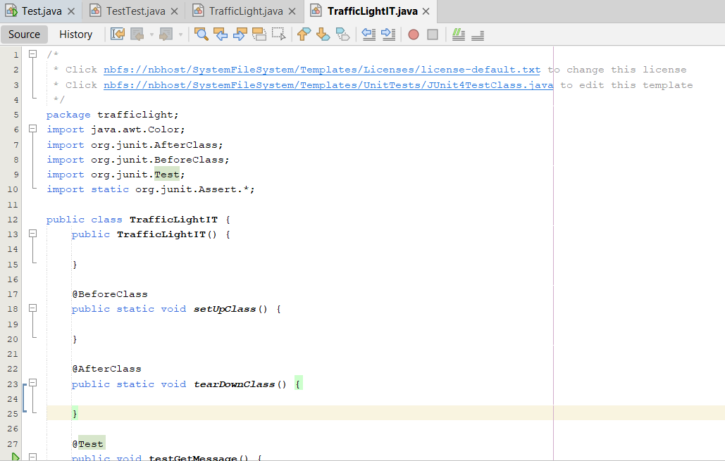
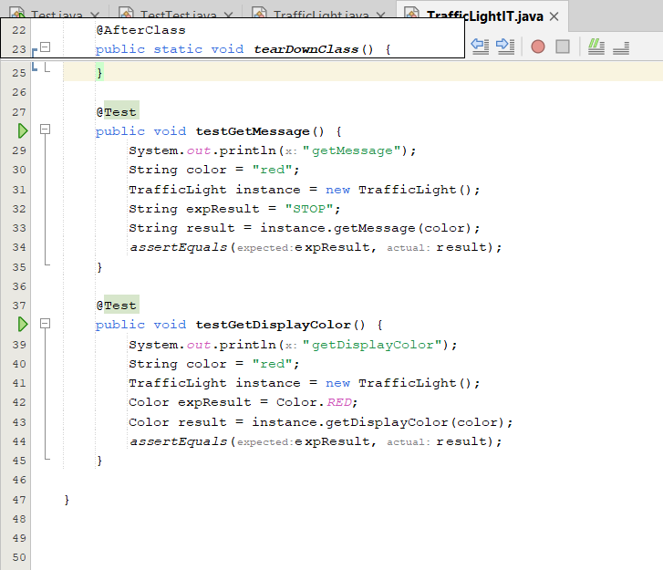

Test Case Output:
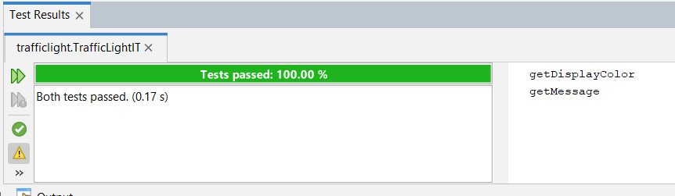

Q2. Demonstrate test-driven development through a java file, Overloading.java, which properly tests the Overloading.java class to ensure that Method Overloading modules are working properly.

Answer:

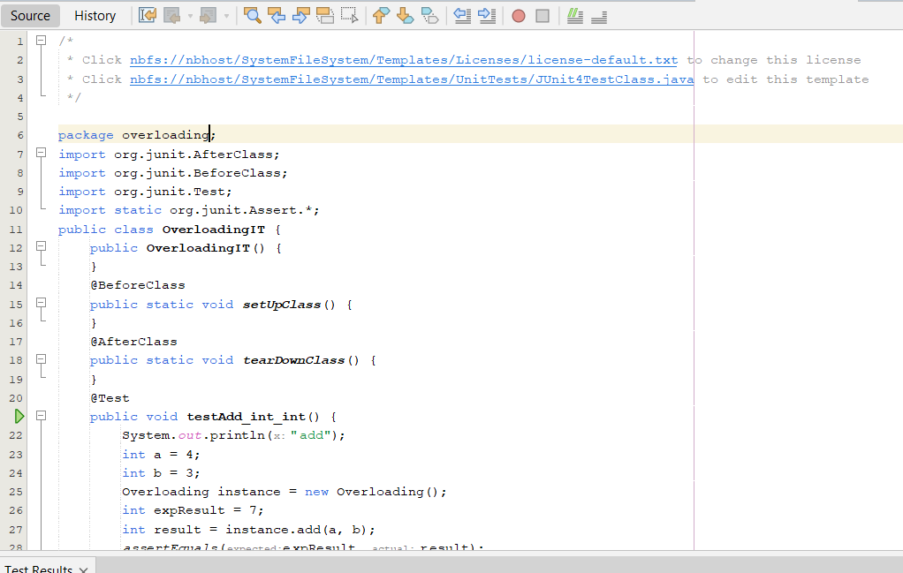
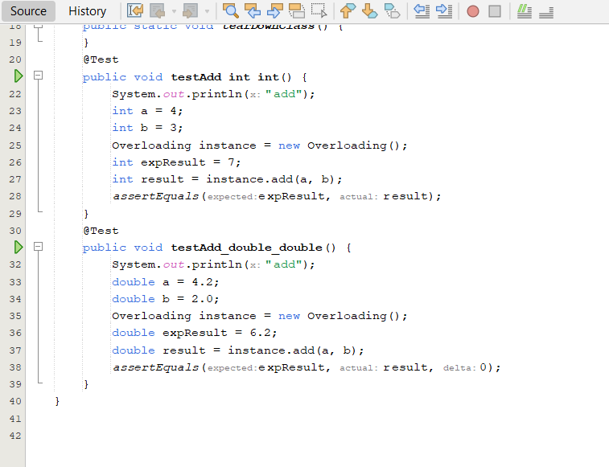

Test Case Output:

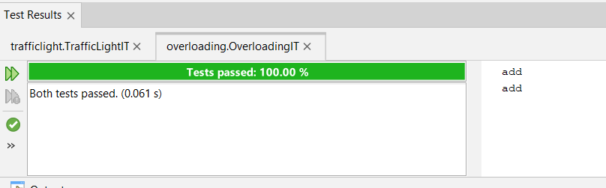

Q3. To study and implement unit testing for a Java program that performs addition of two numbers using JUnit framework.
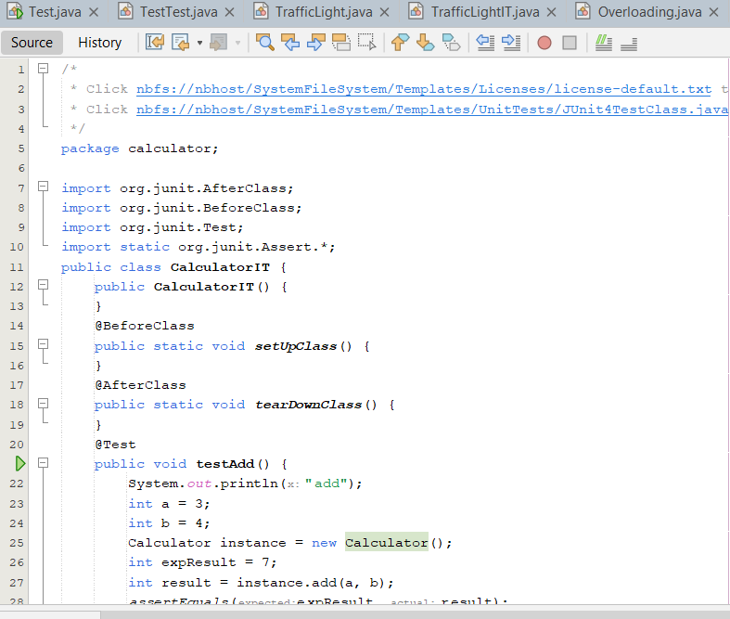
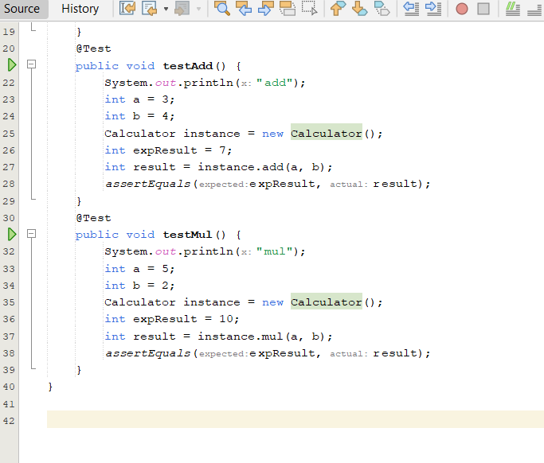

Test case Output:

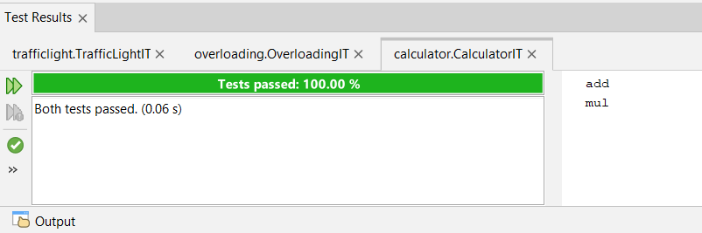

Q4. To design and test a Java program that checks whether a given number is even or odd using JUnit assertion methods.

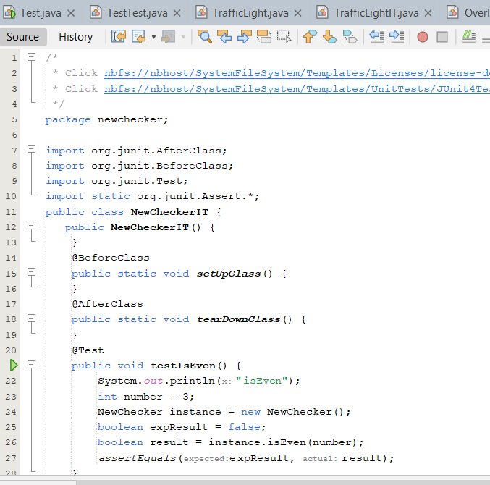
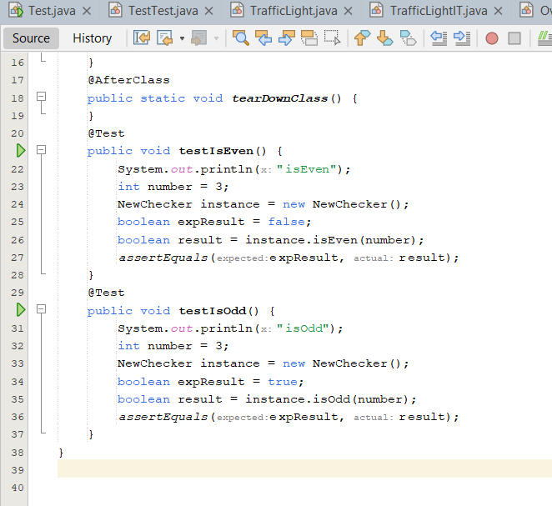

Test Case Output:

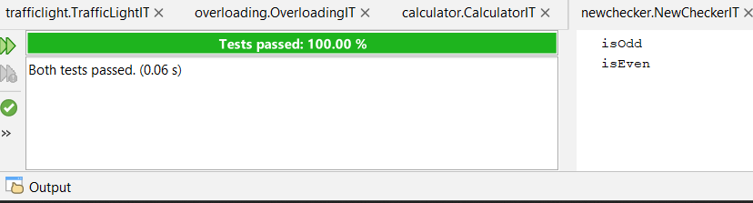

Q5. Implement and test a Java program that verifies whether a given string is a palindrome using JUnit test cases and assertions.


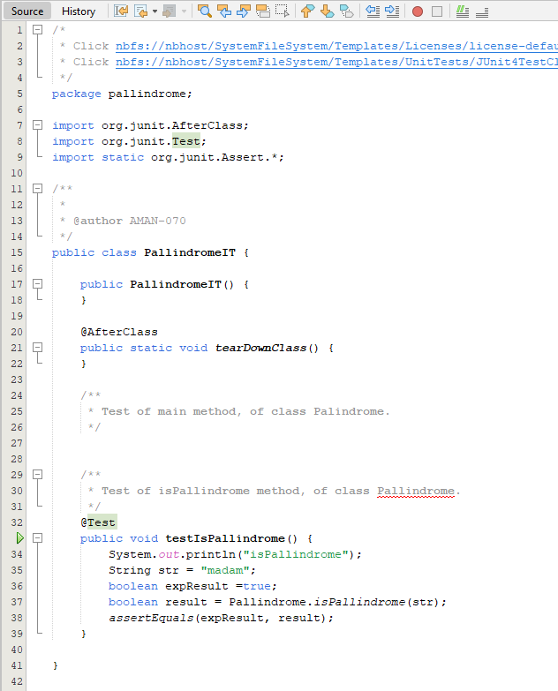

Test Case Output:

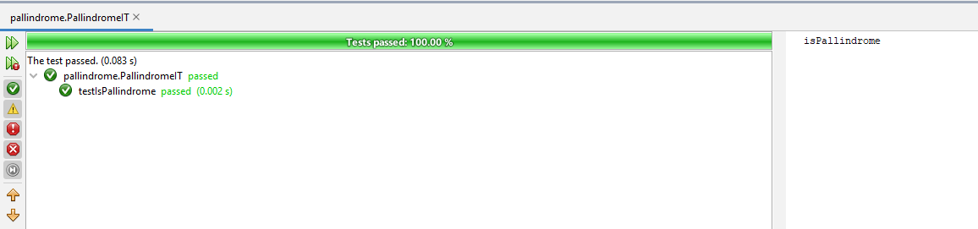

Q6. Demonstrate test-driven development through a Java program to find the maximum of two numbers and test the logic using JUnit framework.


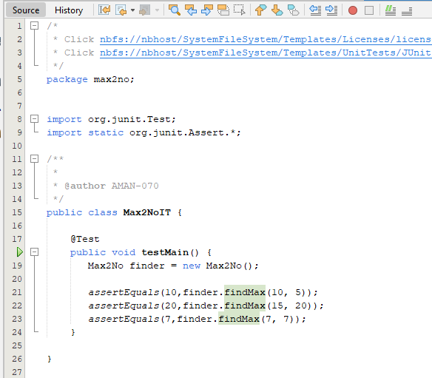

Test Case Output:

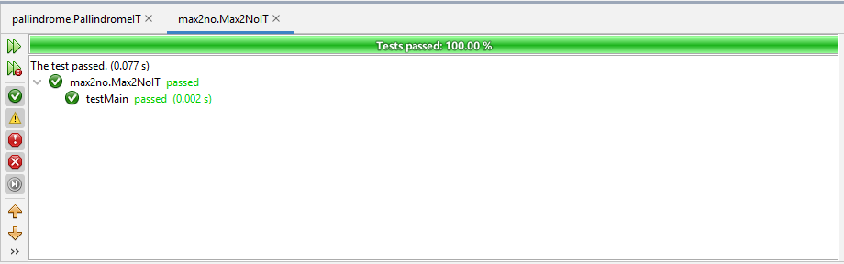

Q7. To create, demonstrate, and implement a Java program to calculate the factorial of a number and verify correctness using JUnit testing.


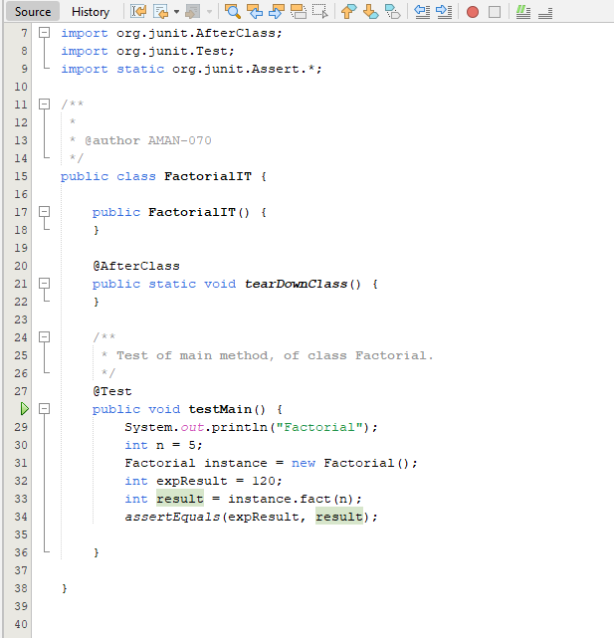

Test Case Output:
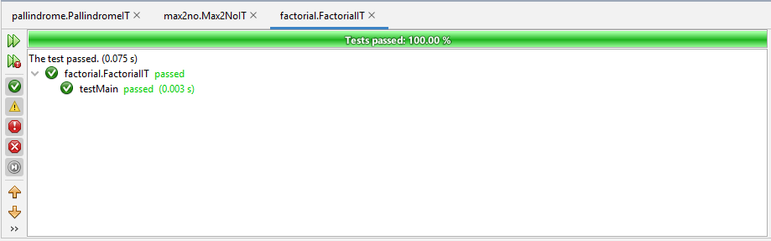
Q8 Demonstrate test-driven development through a simple project called reverse in Net Beans. Reverse a string and test the result using JUnit unit testing methods.

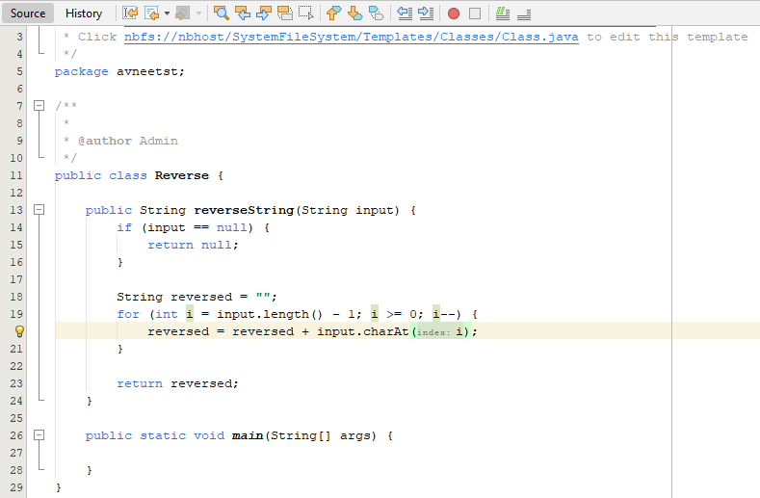
//ReverseIT.java
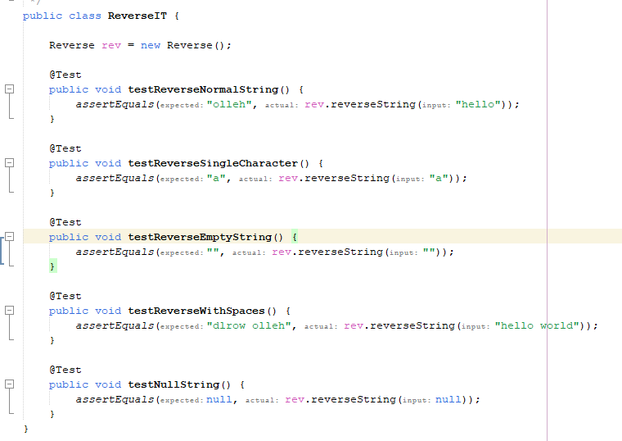

Test Case Output:
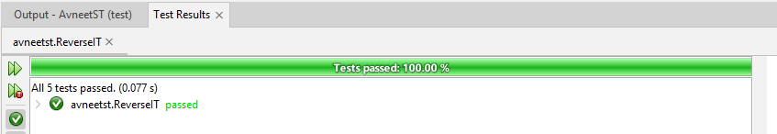

Q9. Create and implement a Java program to calculate simple interest and verify the computation using JUnit test cases.
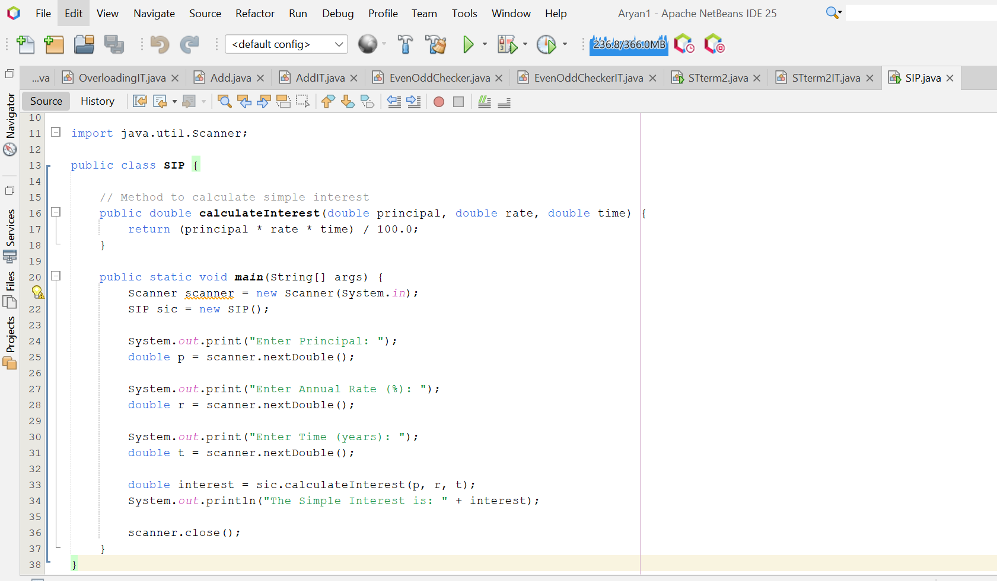
//SIPIT.java
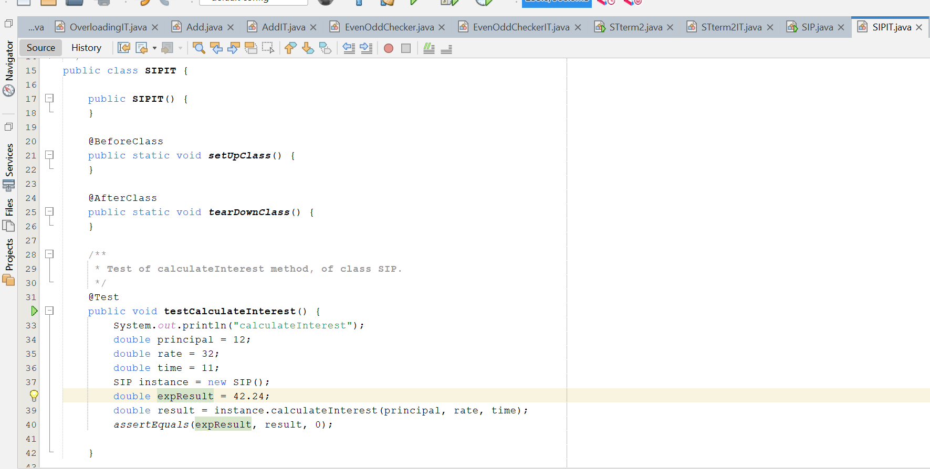

Test Case Output:
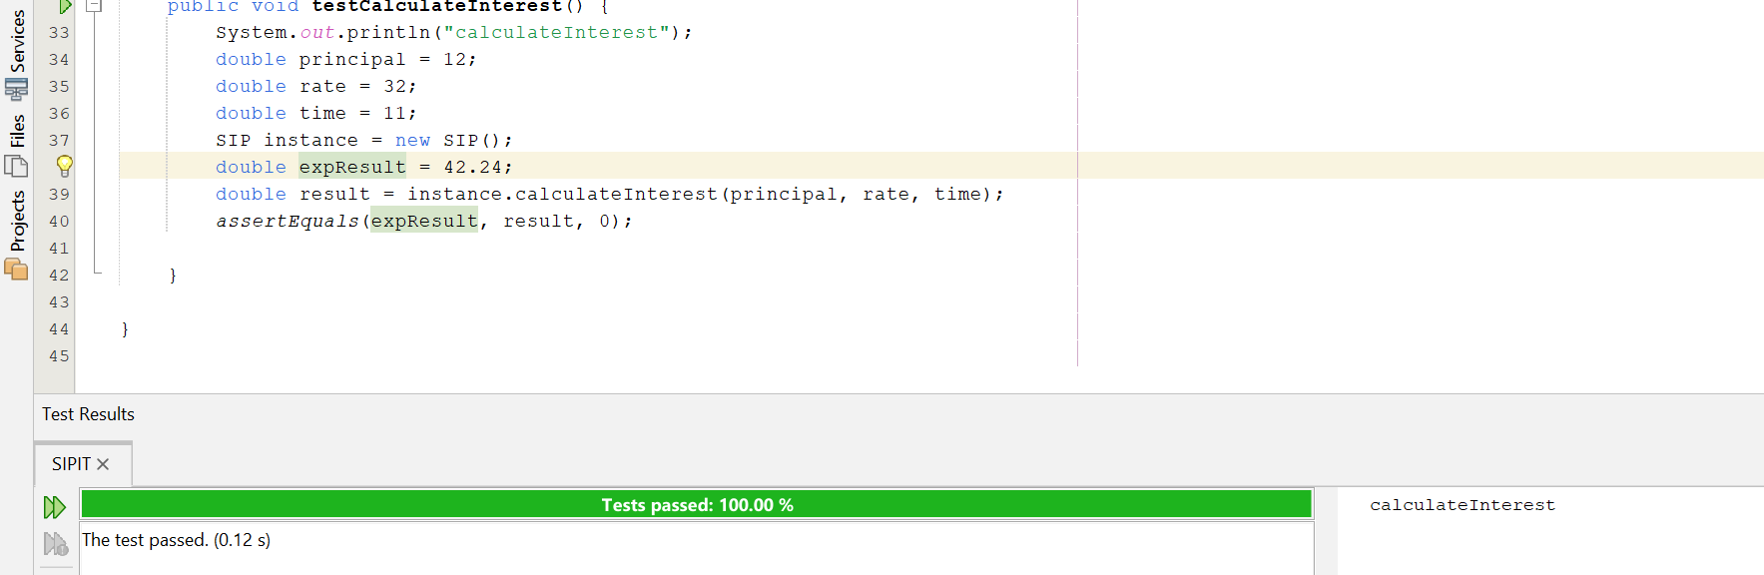

Q10. Construct proper test cases for a Program to validate user login credentials and test different input scenarios using JUnit testing

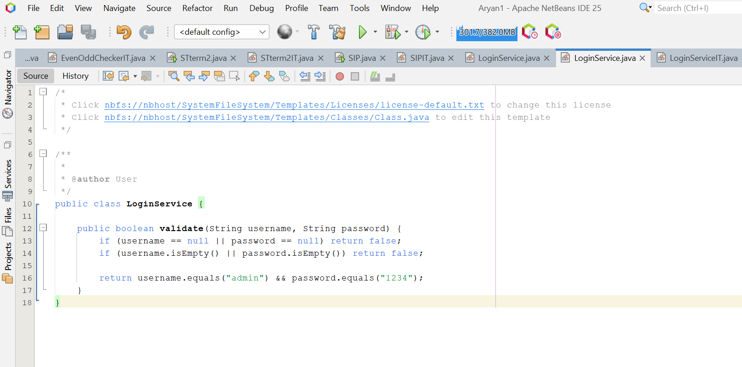
//LoginServiceIT.java
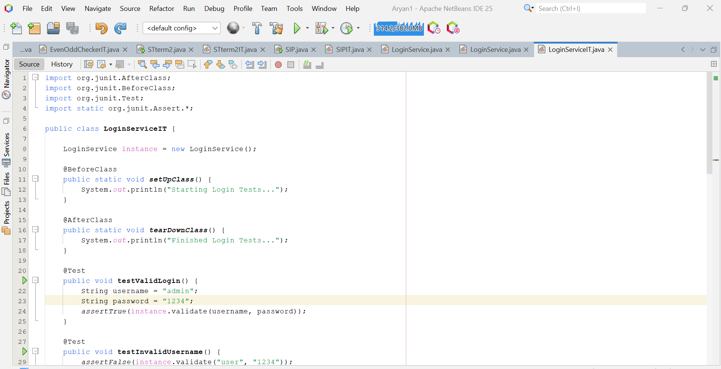
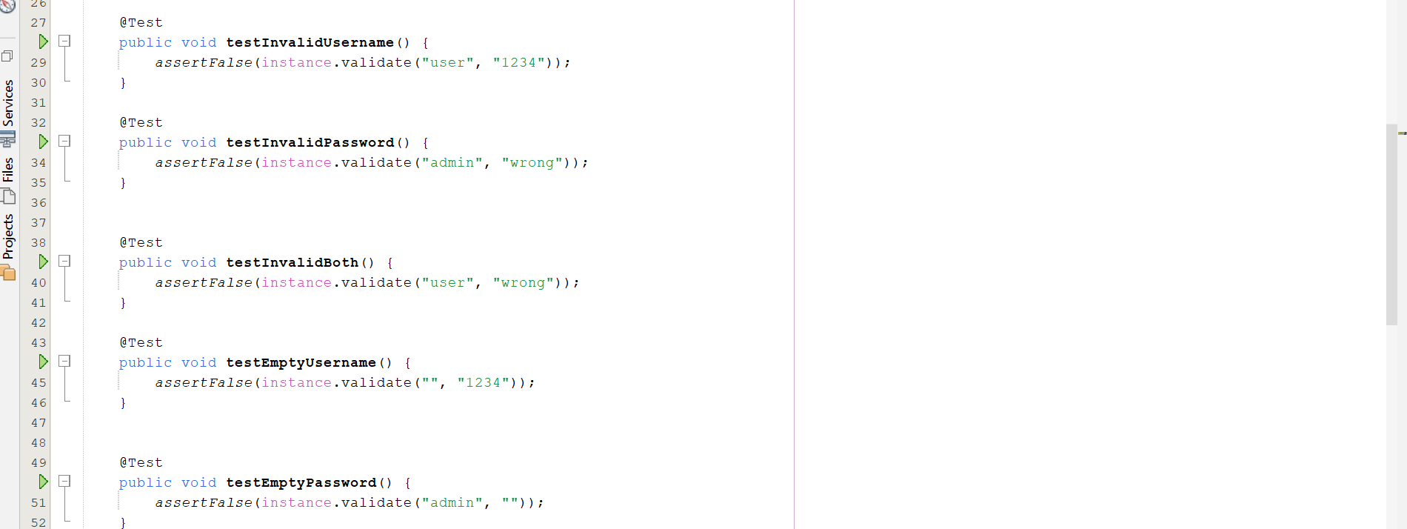
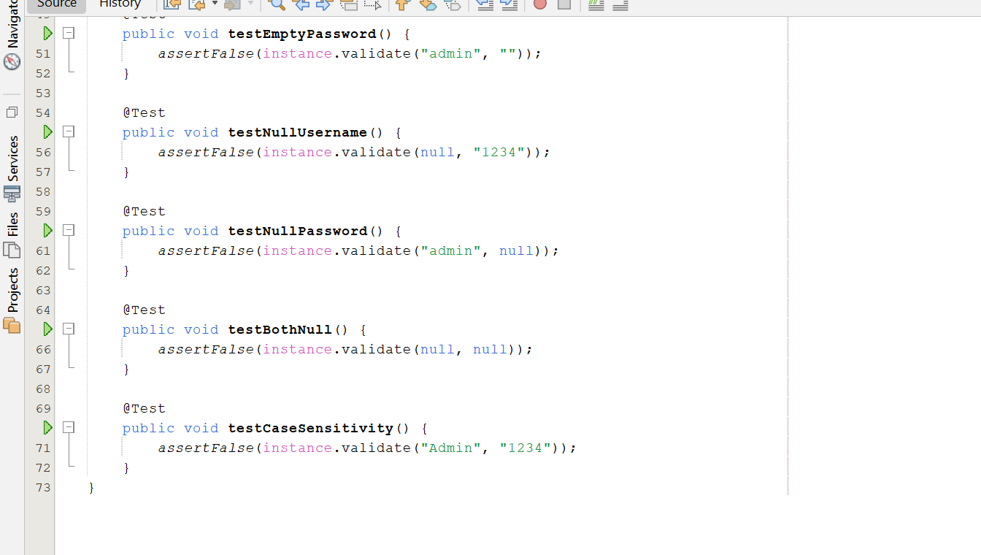

Test Case Output:
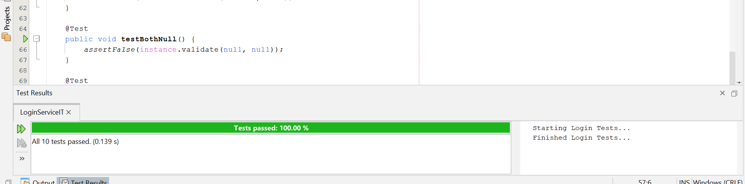

Q11. Construct proper test cases for a general registration form. The test scenarios can be as follows:
- Verify that the registration page loads successfully (all specified fields appear).
- Verify that the required/mandatory fields are marked with * against the field.
- Verify the page has both submit and cancel/reset buttons at the end.
- Verify that clicking submit button after entering all the required fields, submits the data to the server.
- Verify that clicking cancels/reset button after entering all the required fields, cancels the submit request, and reset all the fields.
- Verify that not filling the man

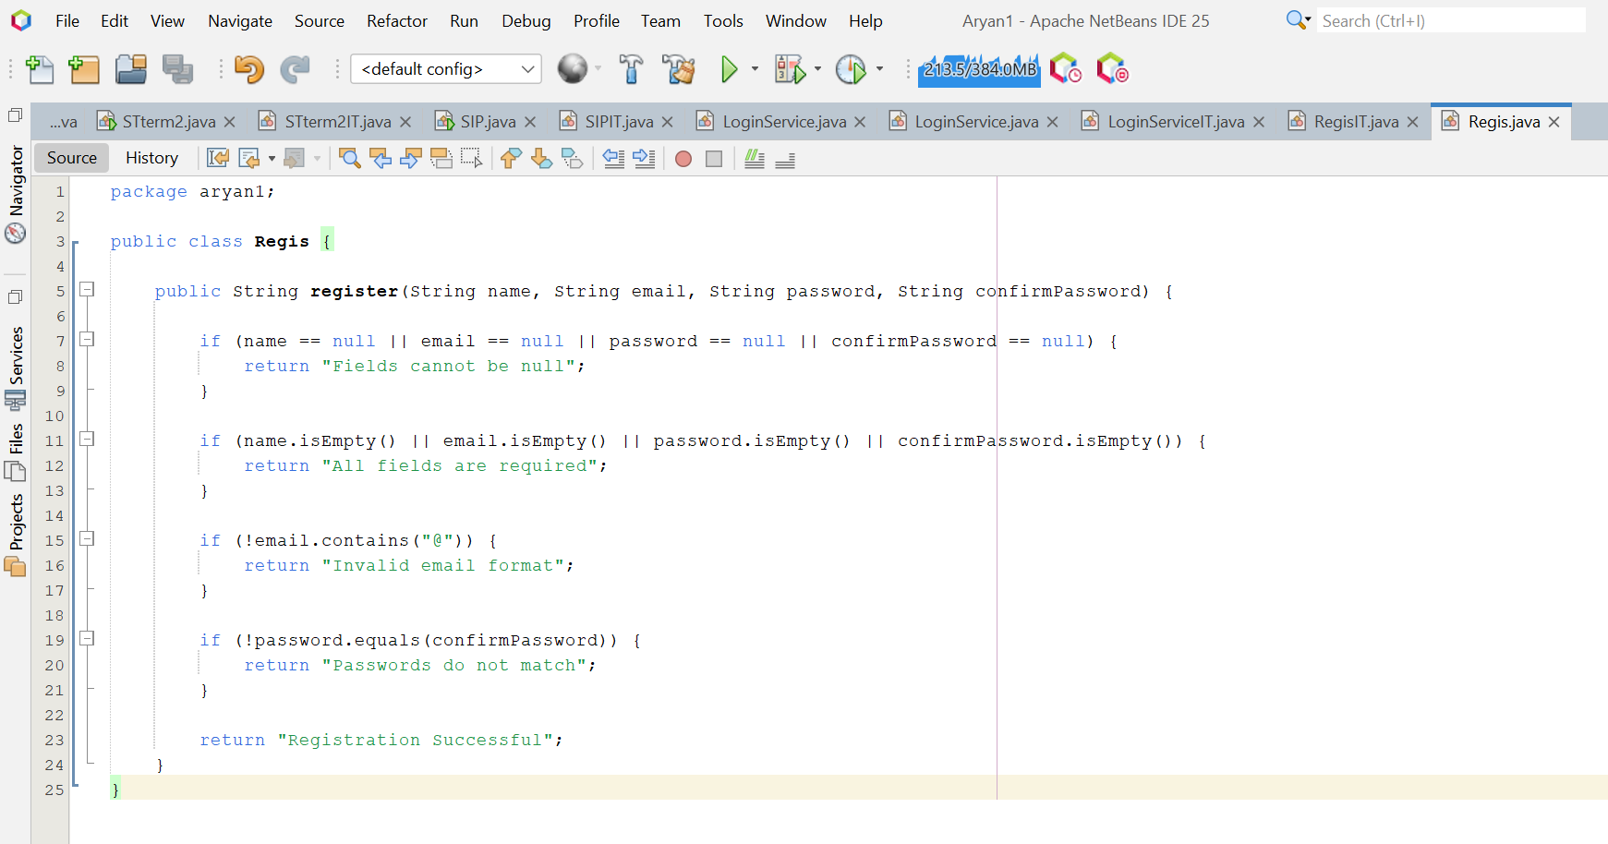
//RegisIT.java
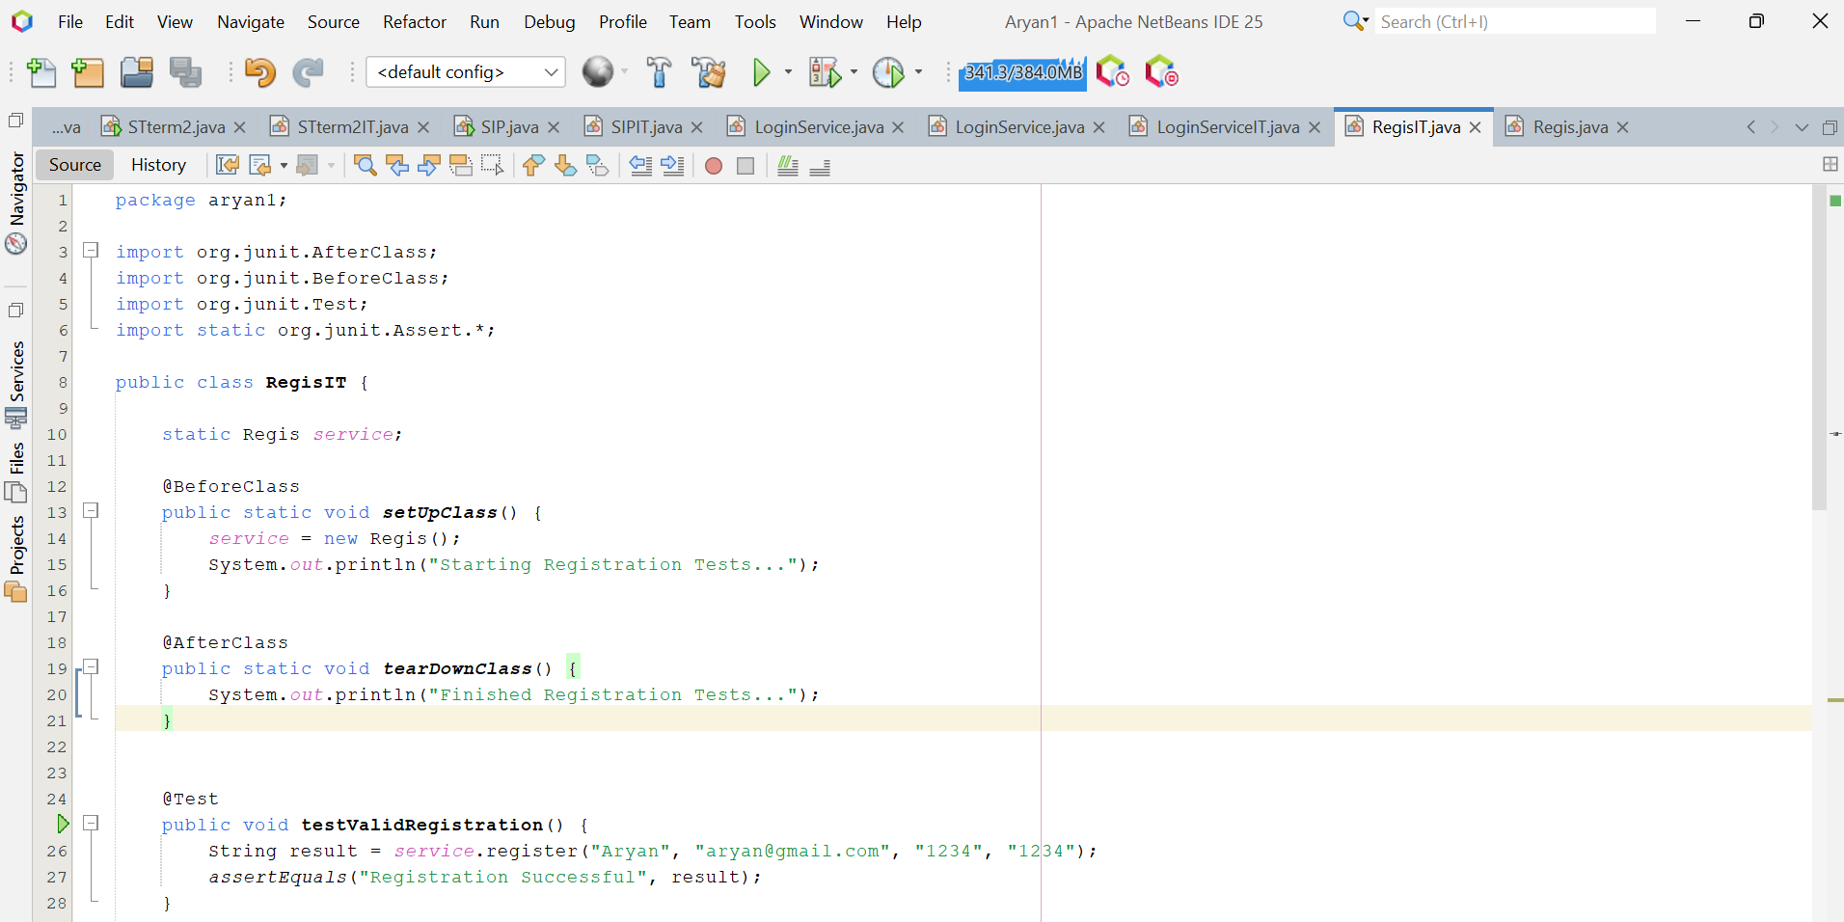
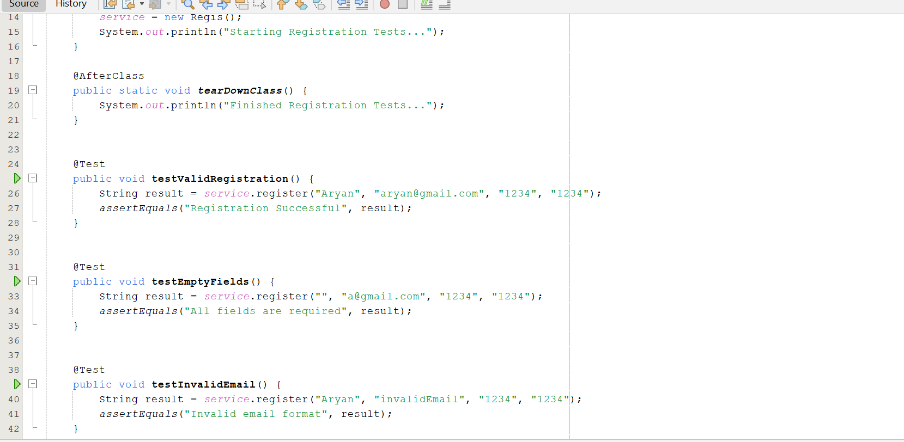
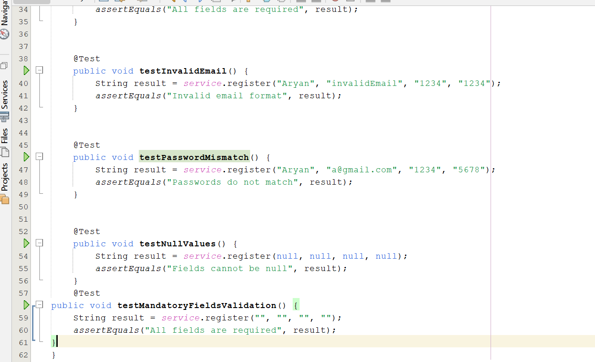

Test Case Output:
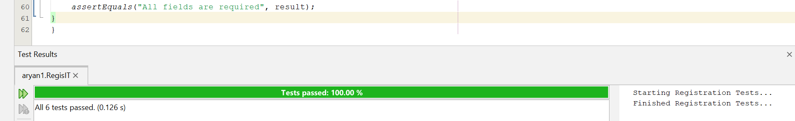

Q12. In the class Arithmetic.java in Q3. Above add another sum() method. Also generate the corresponding sumTest() method through Junit. Execute the Arithmetic Test class for inputs in which test cases fails as well as inputs where test cases pass. Record both test cases in proper test case templates

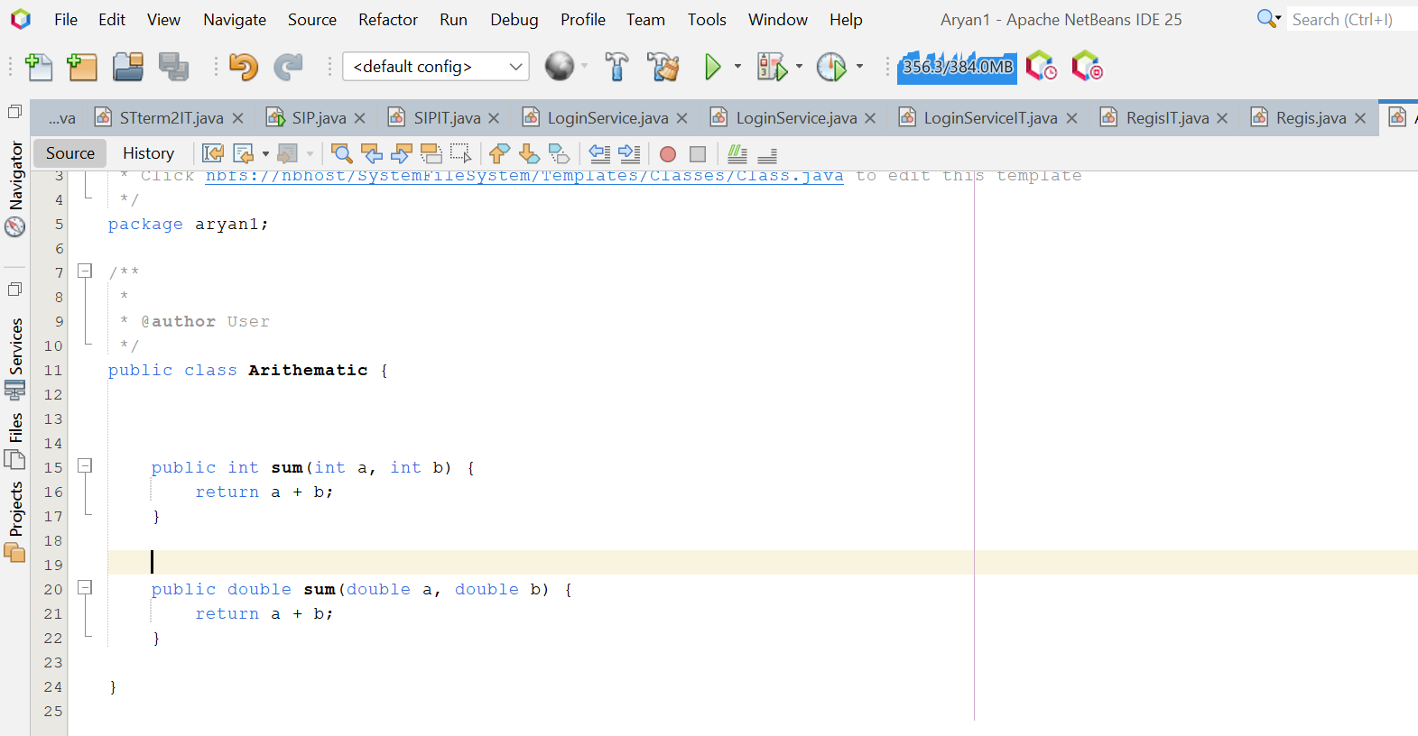
//ArithmeticIT.java
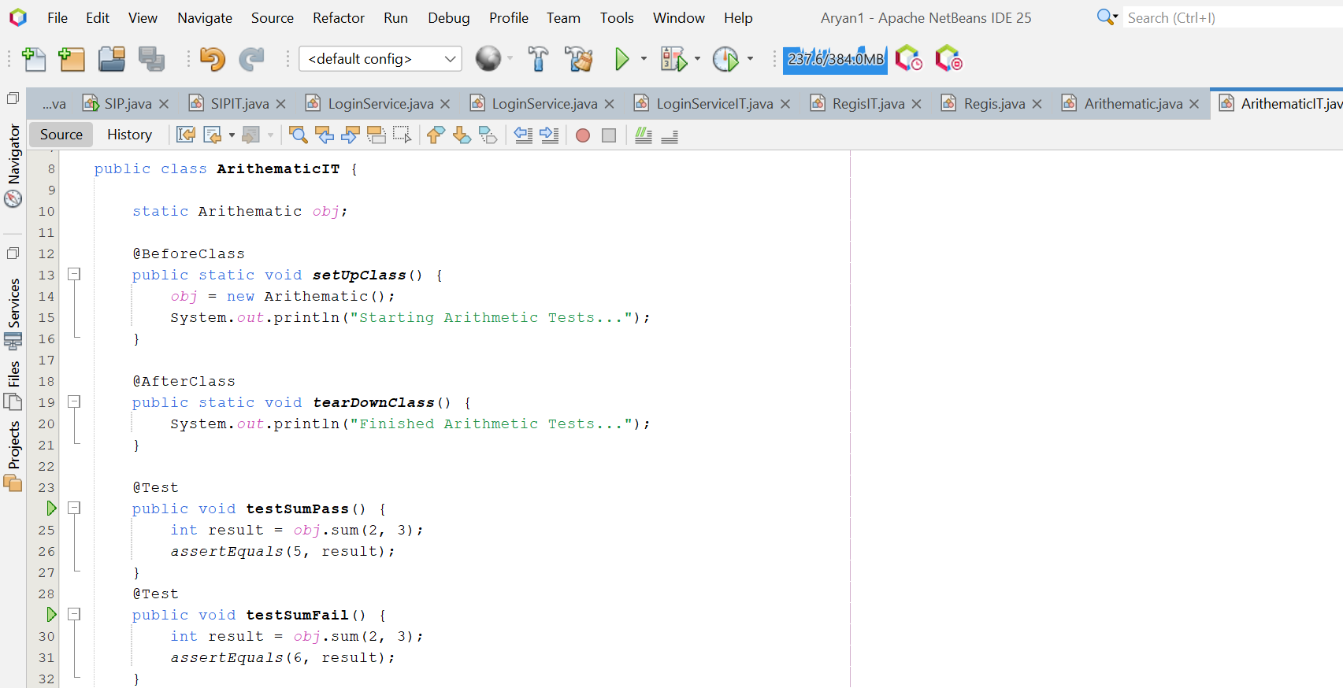
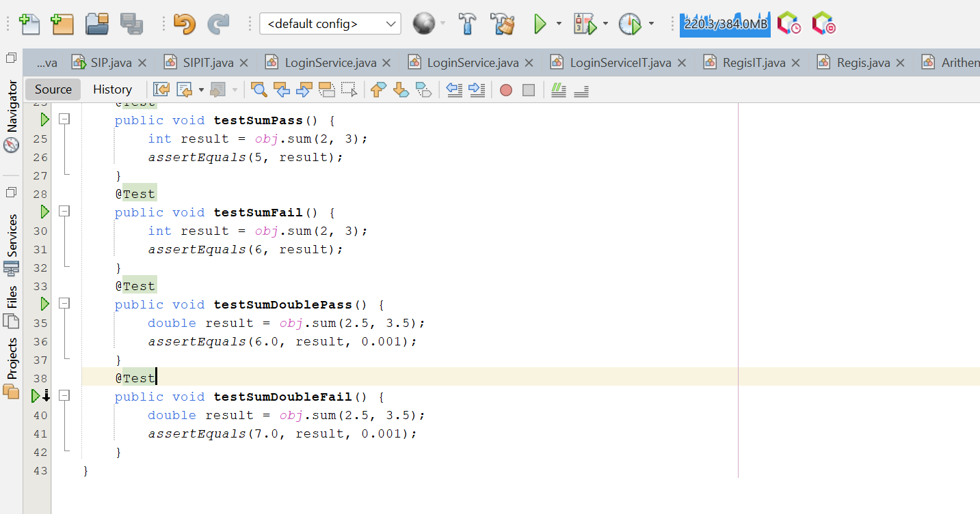

Test Case Output:
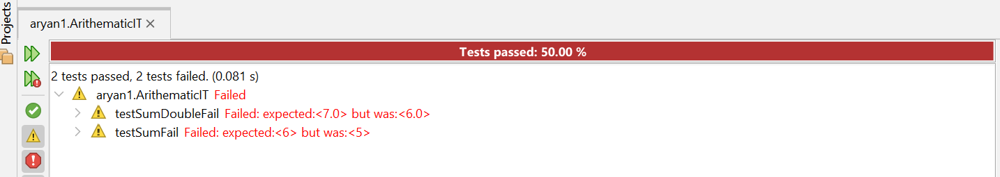

Q13. Demonstrate test driven development through a project Project Repository. The project should contain a class ProductRepository with appropriate methods for CRUD operations on a ProductRepository instance. Through JUnit create corresponding Test classes for each class. Aggregate these different tests in a test suite and execute the same.
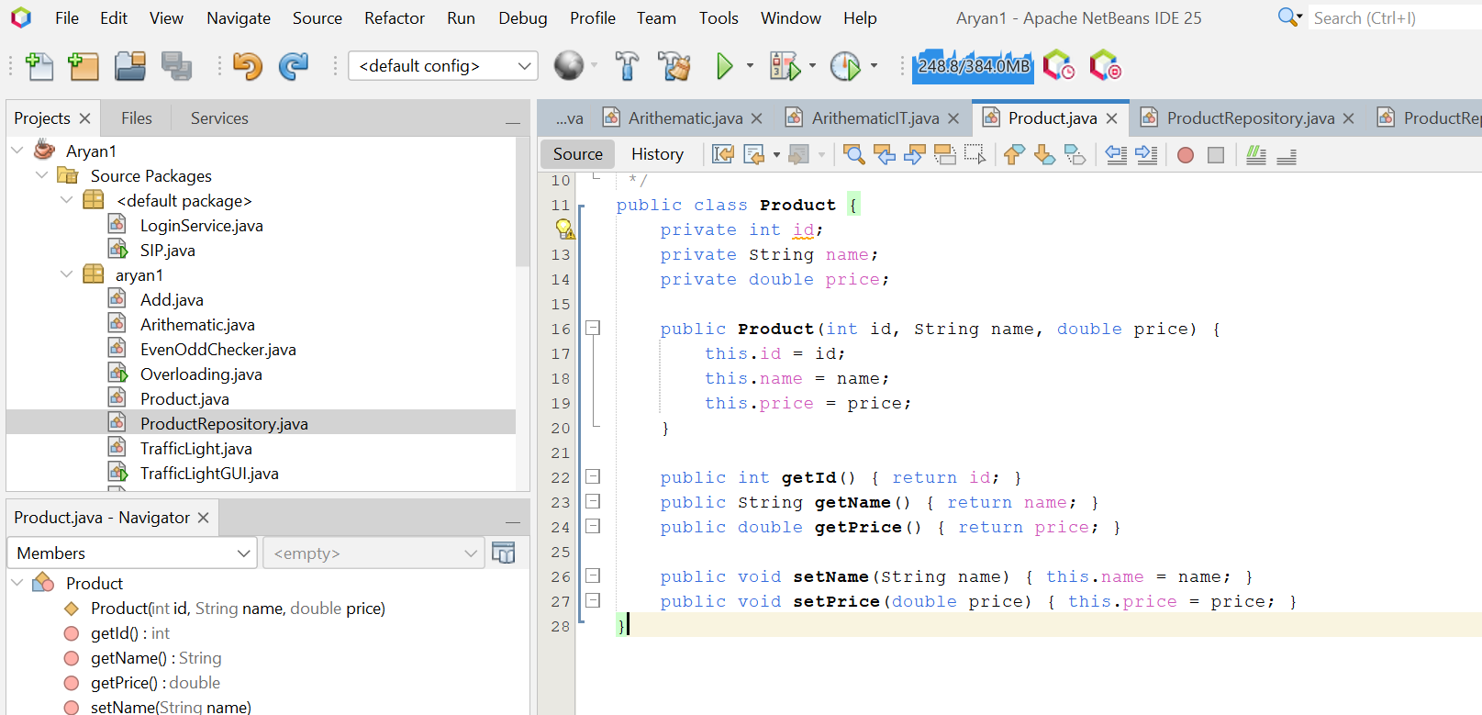
//ProductRepository.java
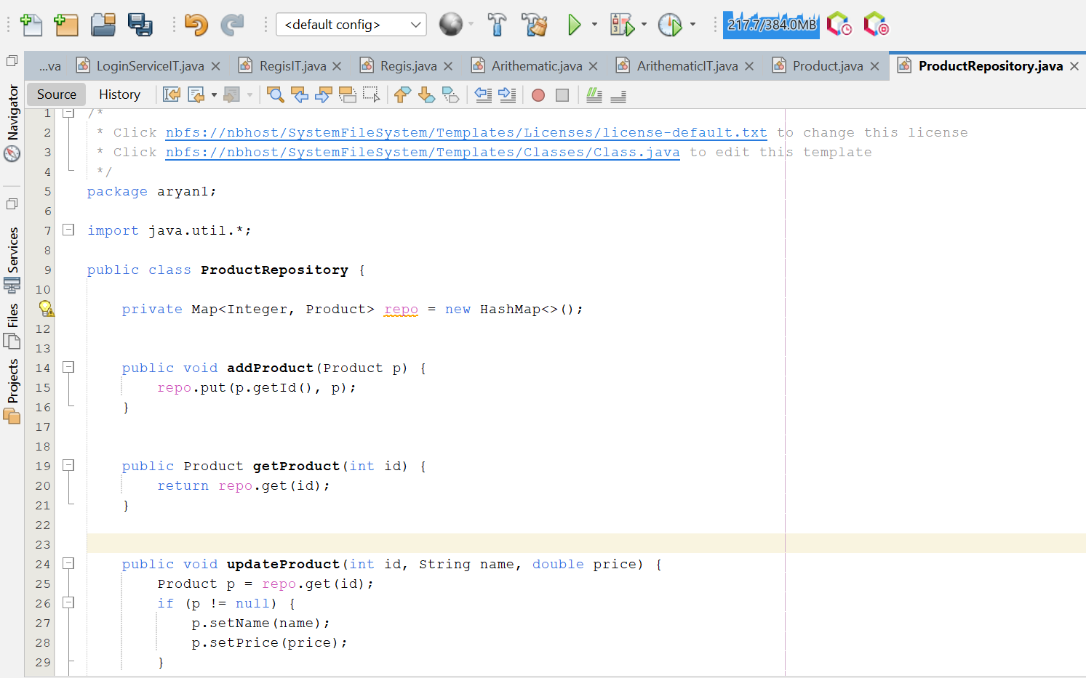
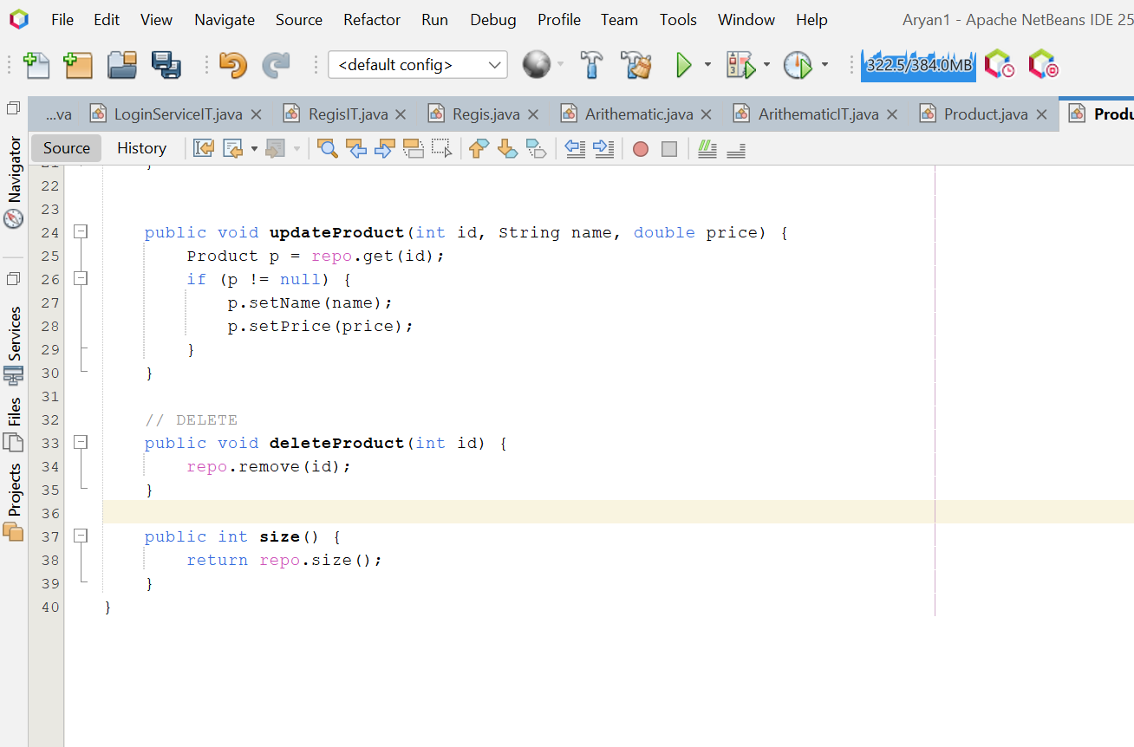
//ProductRepositoryIT.java
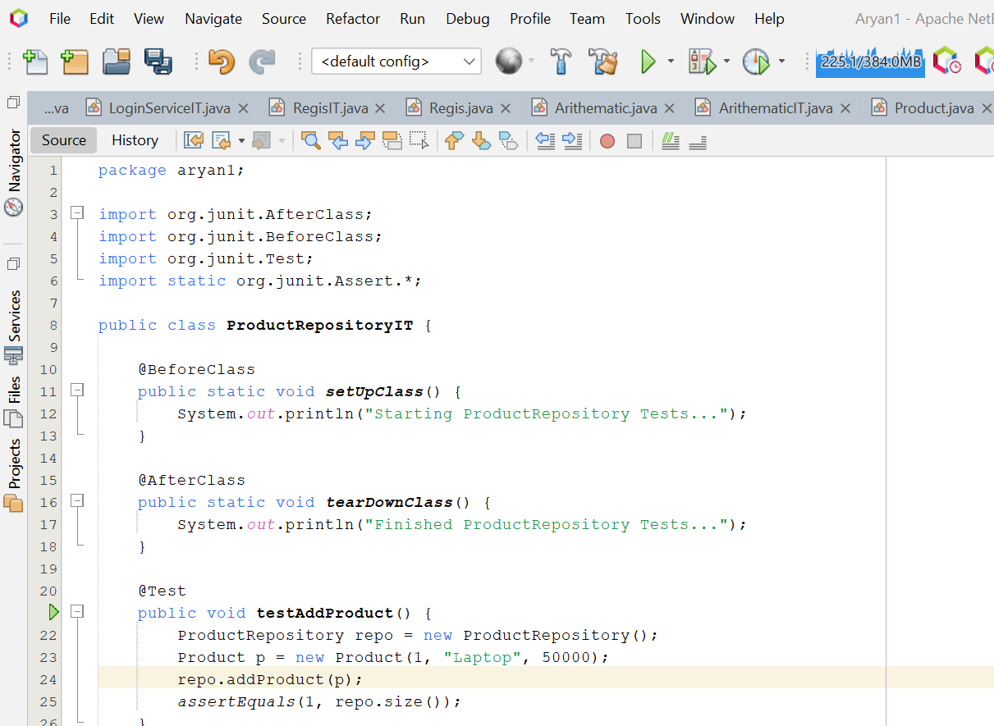
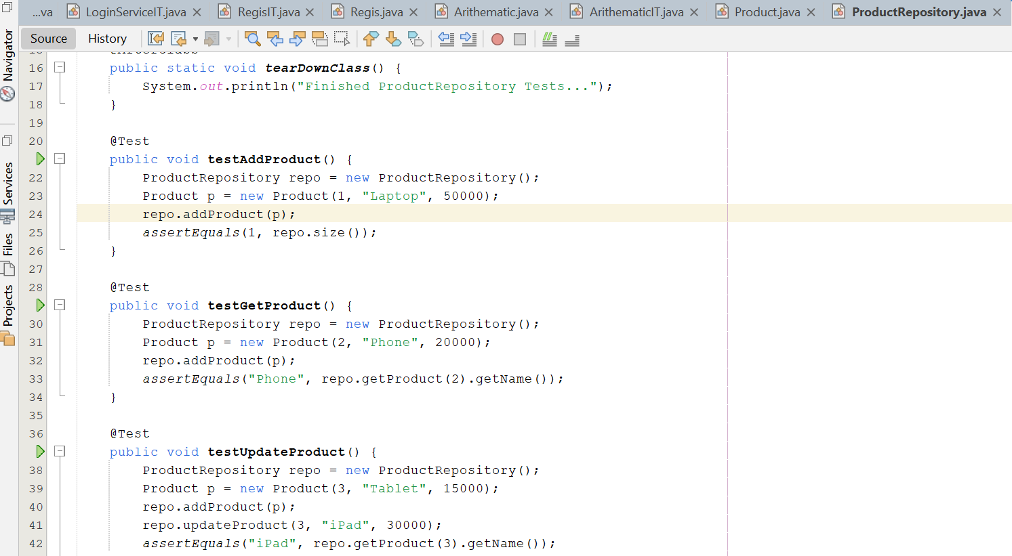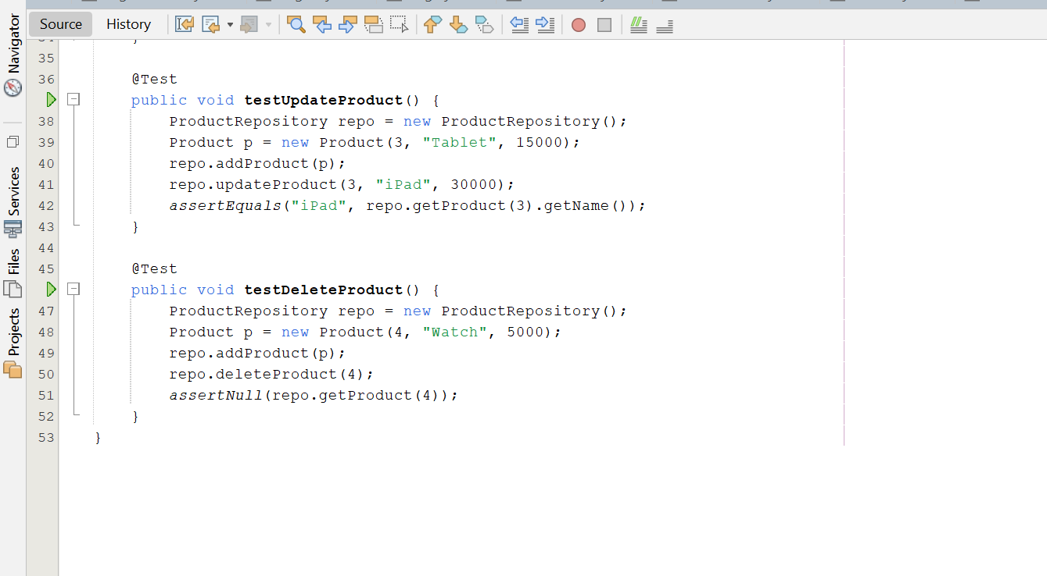
Test Case Output:
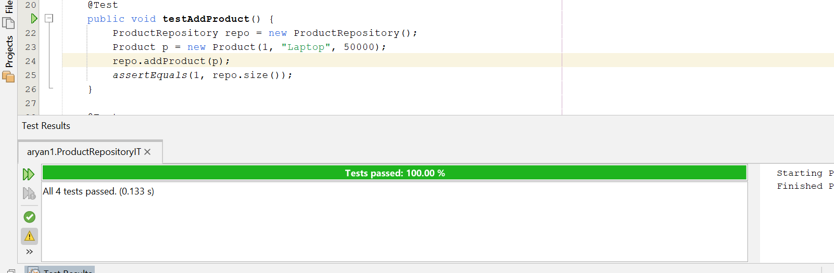
Q14. Demonstrate test driven development through a project Addition. The project should contain a class Addition with appropriate methods for returning the sum of two numbers. Through JUnit create corresponding Parameterized Test classes and TestRunner classes to execute the above test on a collection of test cases. The test cases should be chosen using boundary value analysis technique for an input range from [1-10] for the first number and [11-20] for the second number.

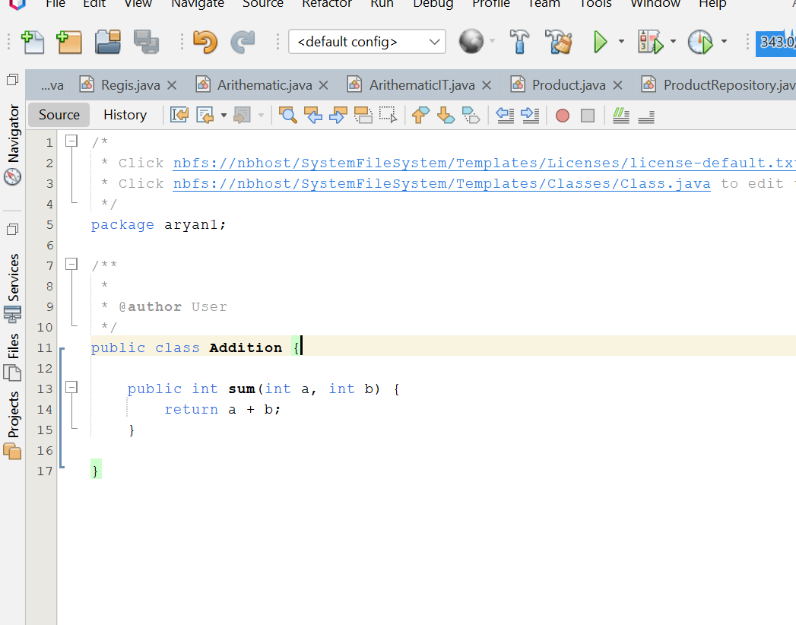

//AdditionIT.java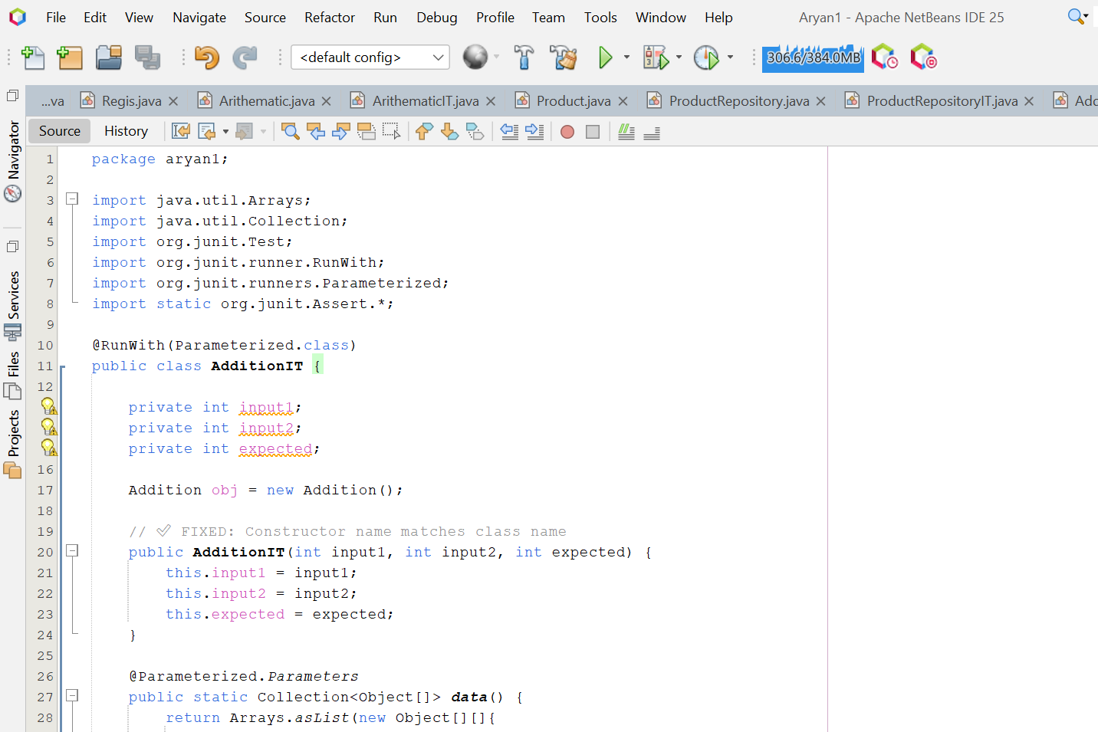 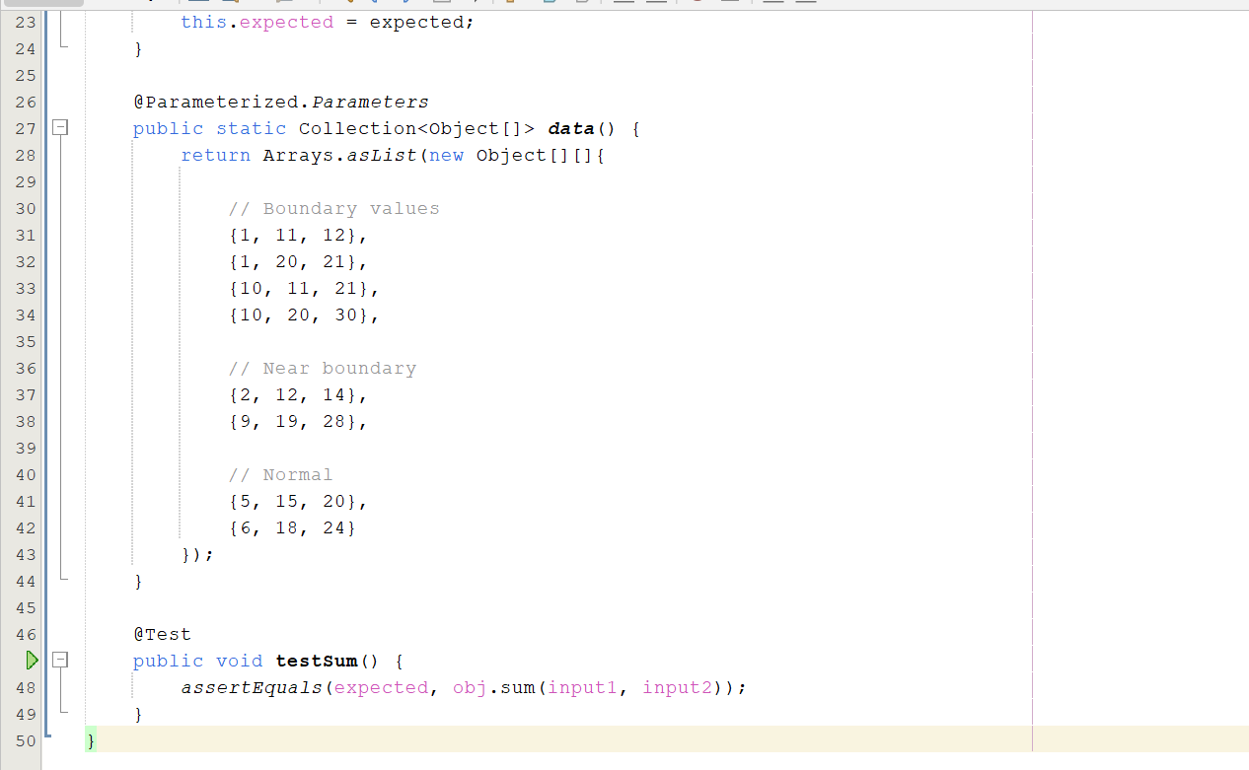

Test Case Output:
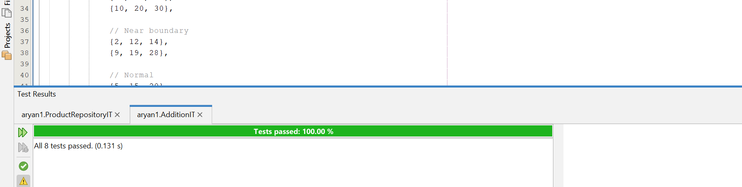

Q15. Demonstrate test driven development through a project MessageUtility. The project should contain a class MessageUtil with appropriate methods for printing a Message .Through JUnit create corresponding Test classes and TestRunner classes to execute and test the above class

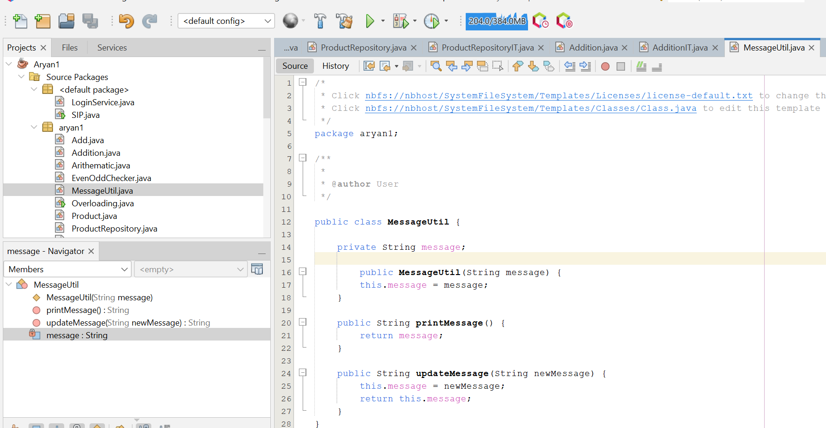
//MessageUtilIT.java

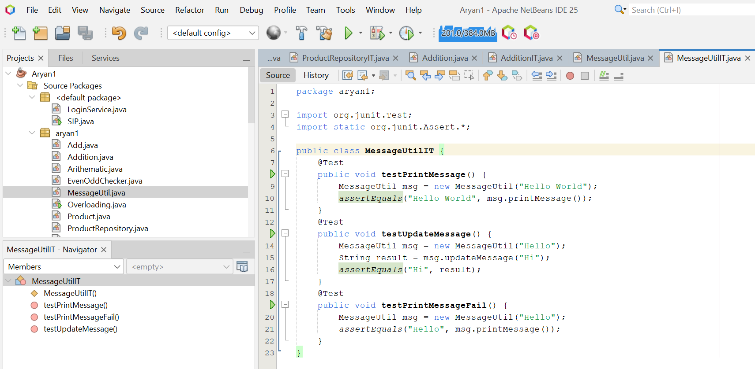
Test Case Output:
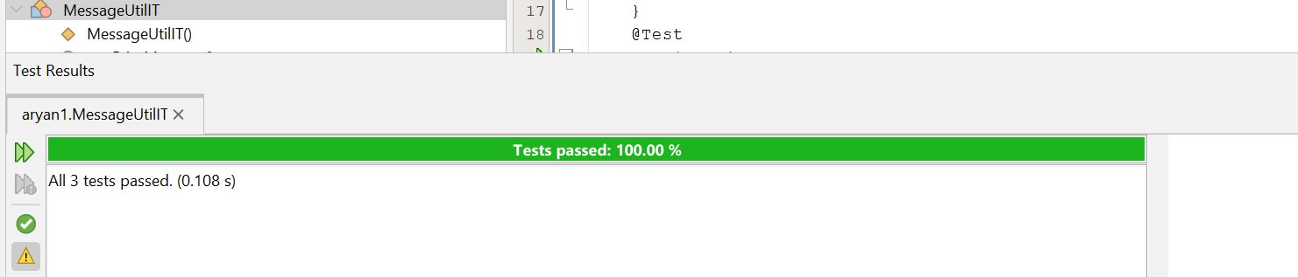

Q16. Create a new project called AssertClass. Refactor the test class and TestRunner
class of question 15 to demonstrate the assertion methods of the assert class to
write useful test.


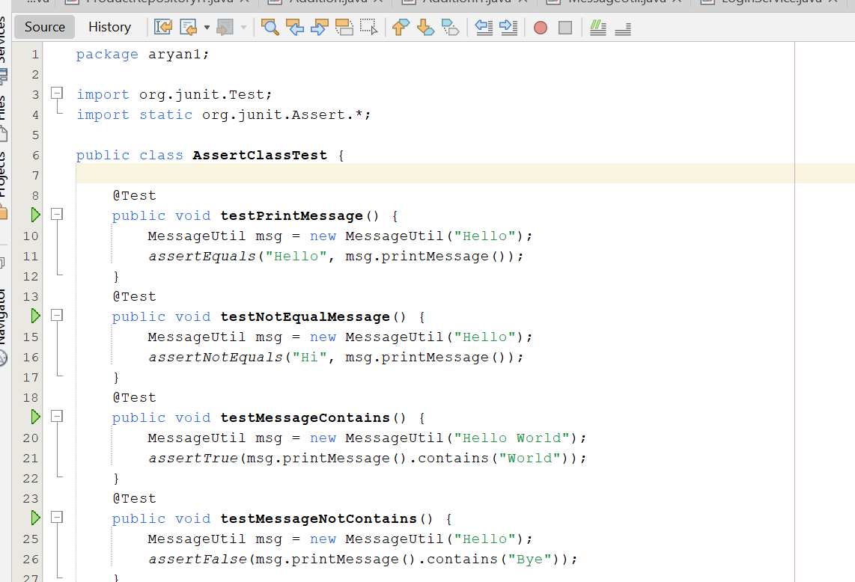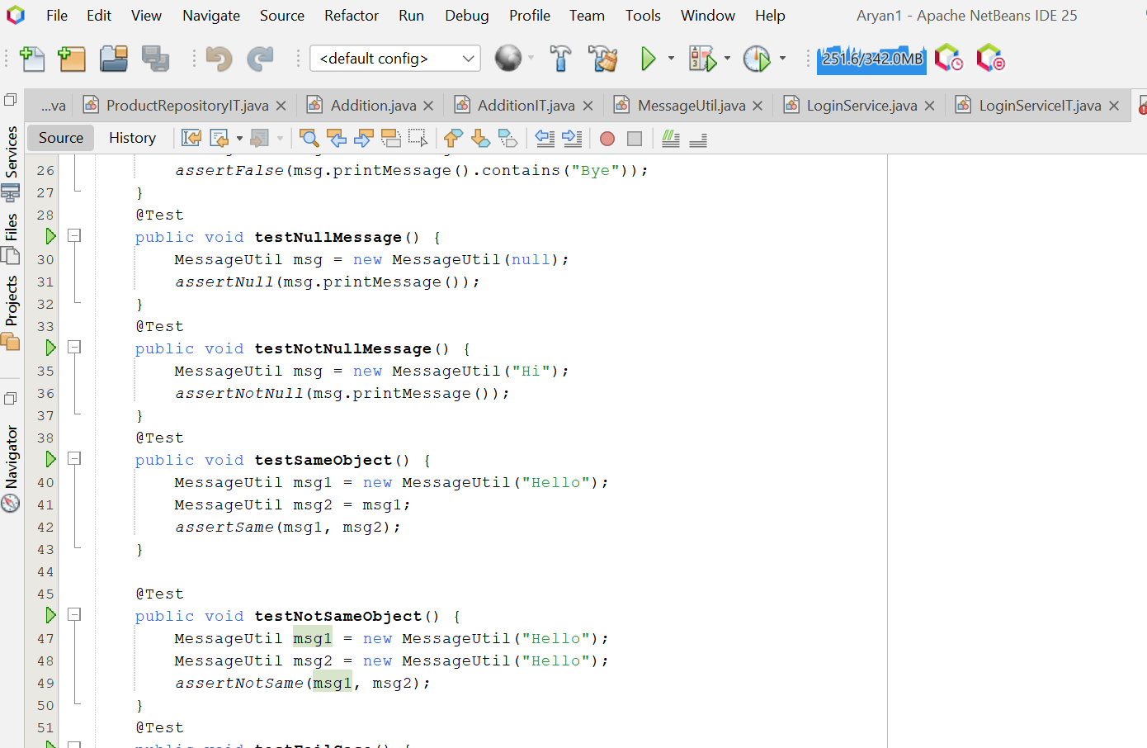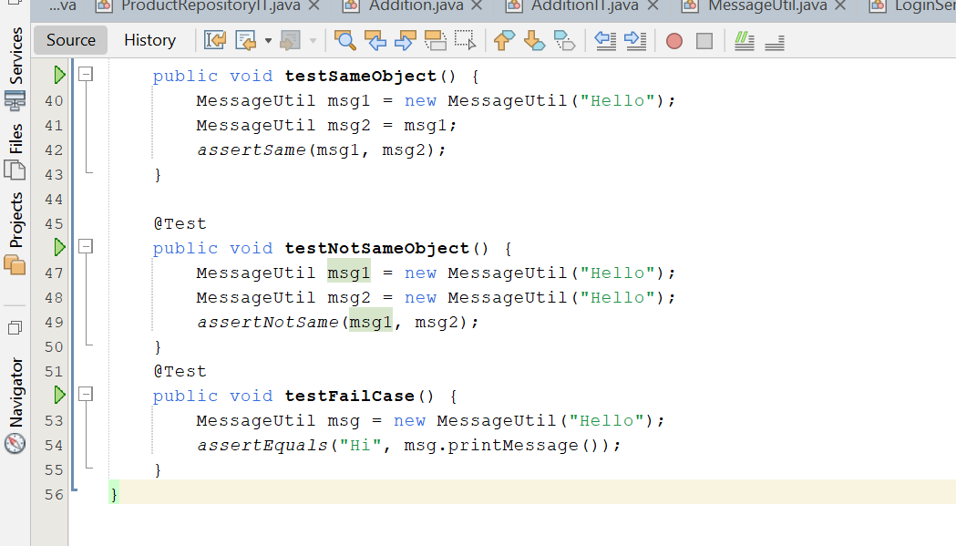
Test Case Output:
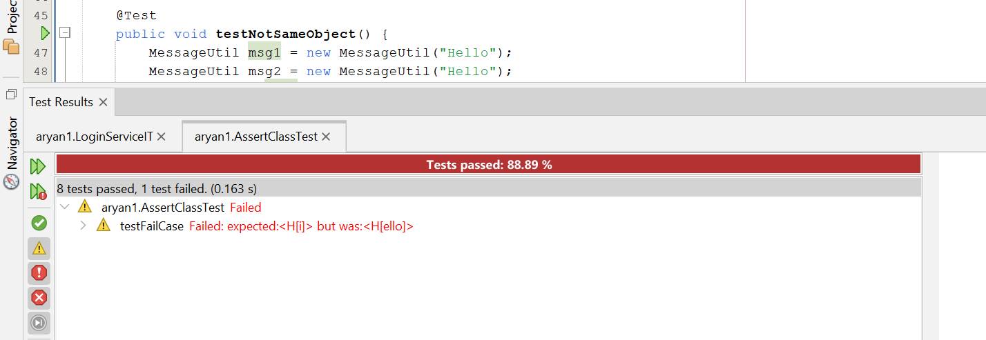

Q17. Create optimal parametrized tests for the login web page of a company website say XYZ Corporation. The Login feature is governed by the following specifications: • A user can enter a valid email or invalid email. • The user’s email is in the database. • A user enters a correct or incorrect password (a password that doesn’t fit the account or password is invalid). • A user can be blocked.

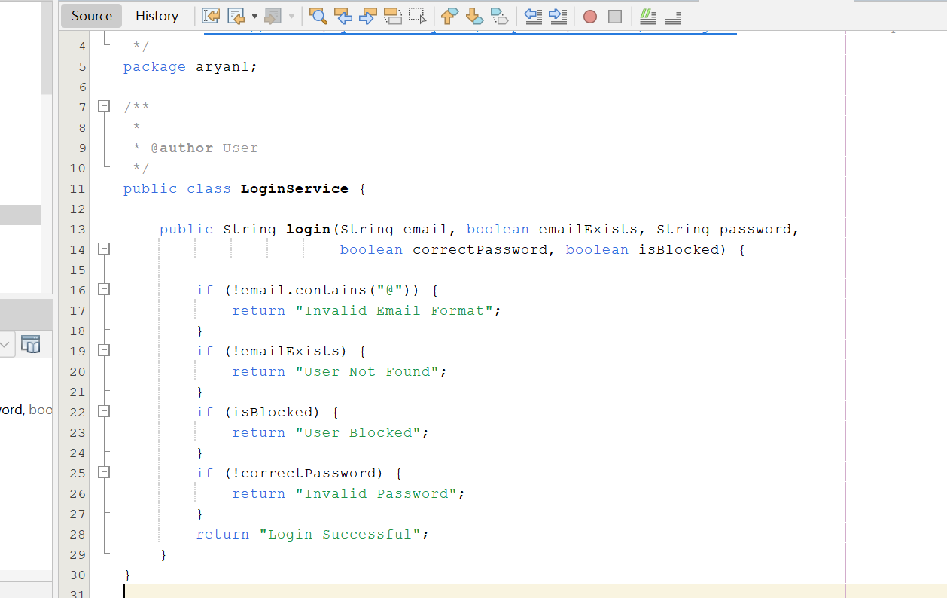
//LoginServiceIT.java

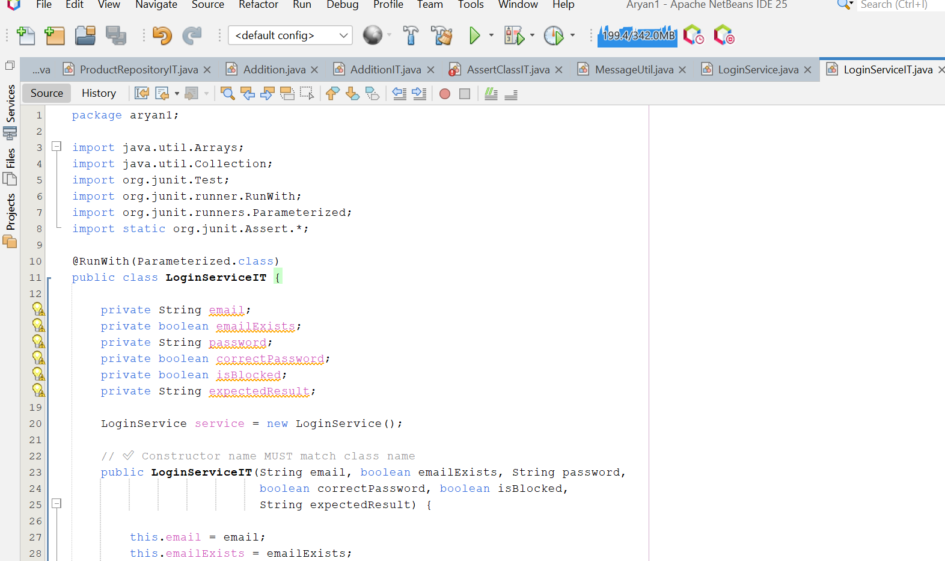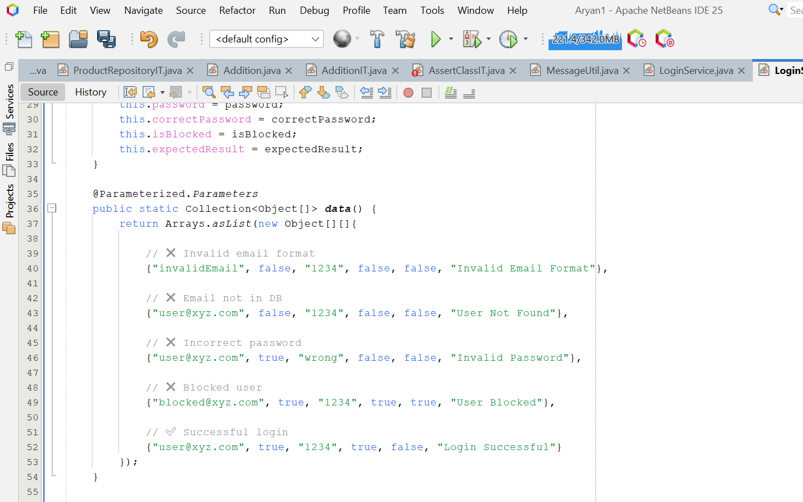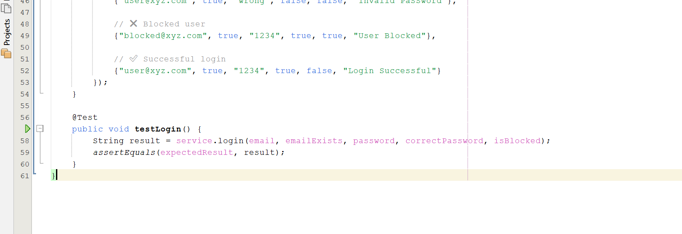

Test Case Output:
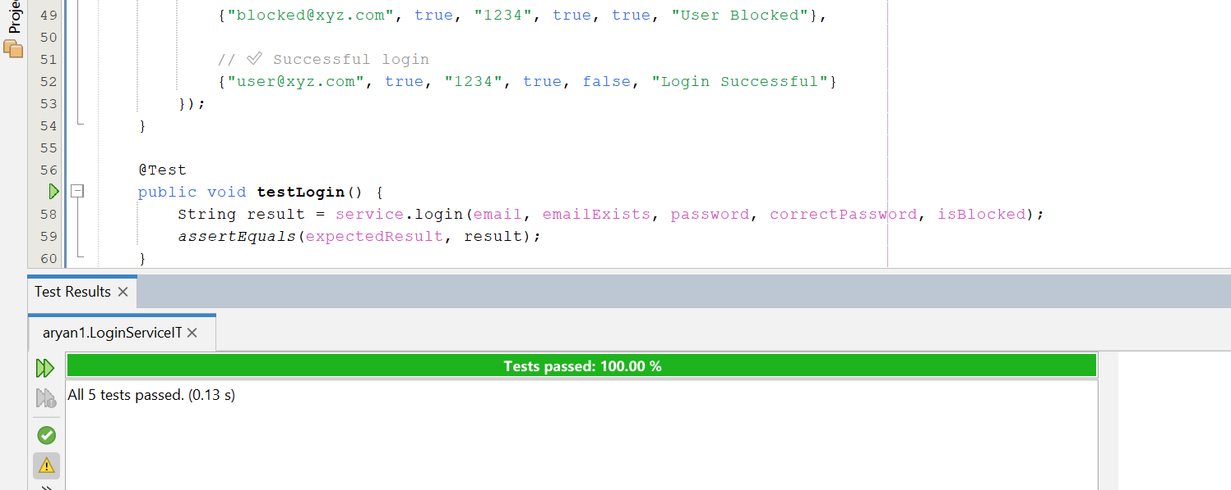
Q18. Create a trivial class Counter with the following: -The constructor will create a counter and set it to 0 -The increment method will add one to the counter and return the new value. - The decrement method will subtract one from the counter and return the new value. Write test methods to test these methods. Also create a TestRunner class to execute these methods.

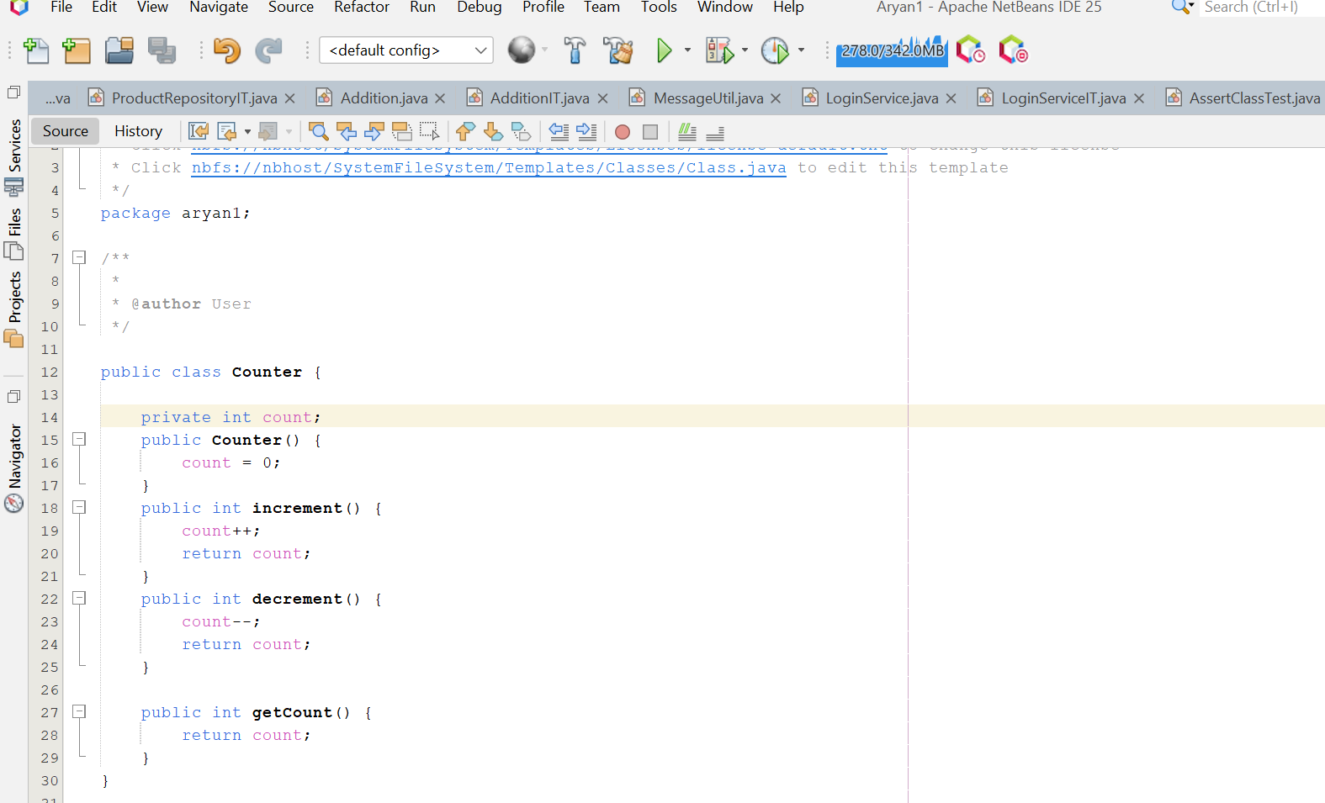
//CounterIT.java
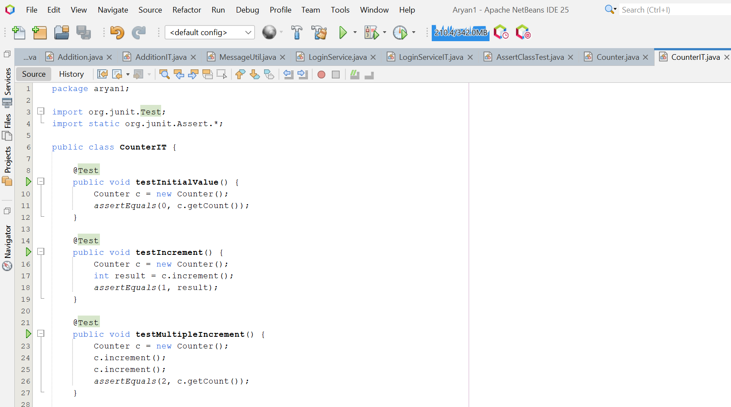
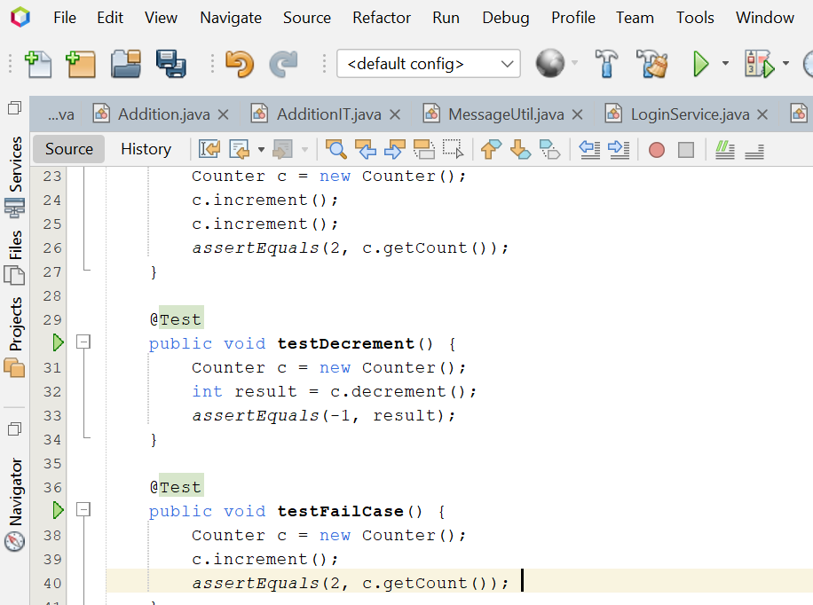

Test Case Output:
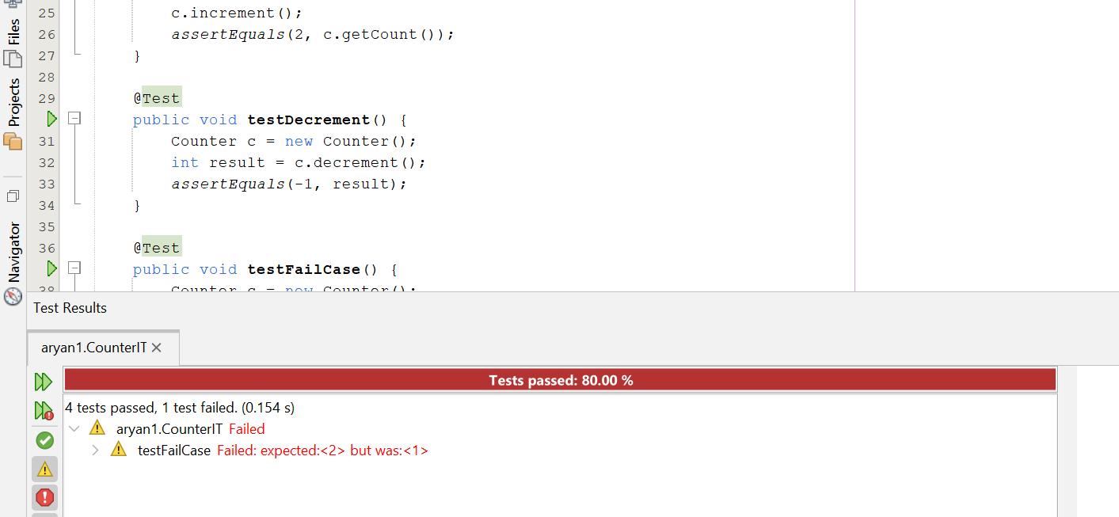

Q19. Demonstrate test driven development through a project Project Repository. The project should contain based on the following rules: a) Marks in Mathematics>=60 b) Marks in Physics>=50 c) Marks in Chemistry>=50 d) Total in all three subjects>=160 or e) Total in Maths & Physics>=120 If aggregate of an eligible candidate is greater than 225, he will be eligible for honors course. Write appropriate class to represent this situation. Through JUnit create corresponding Test classes for each class. Aggregate these different tests in a test suite and execute the same
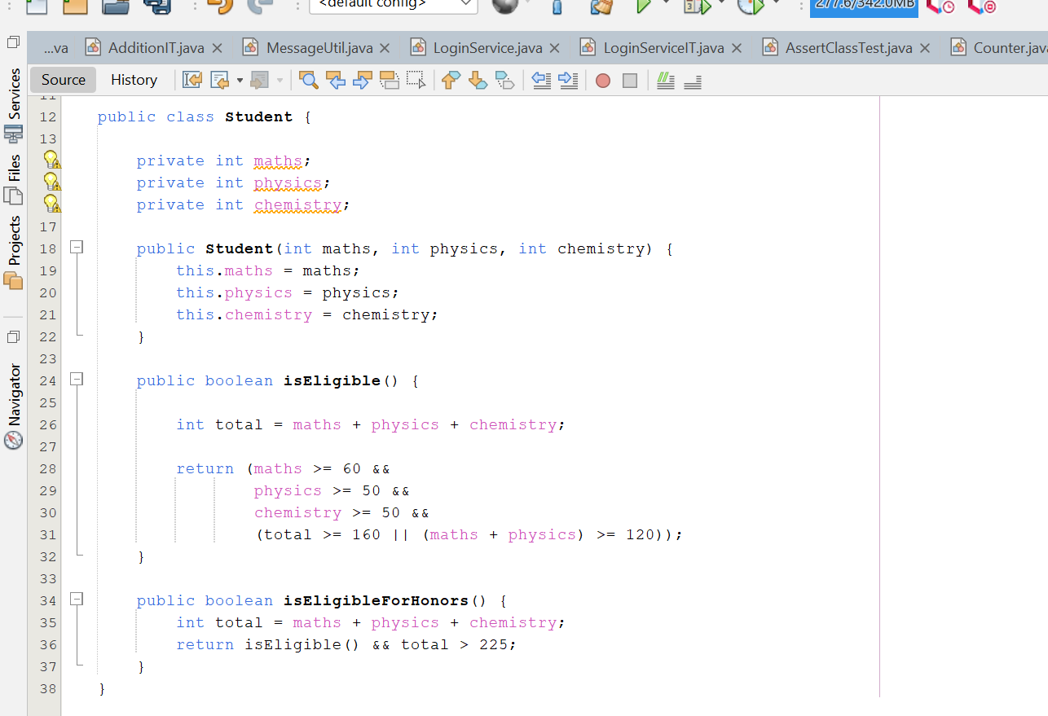

//StudentIT.java

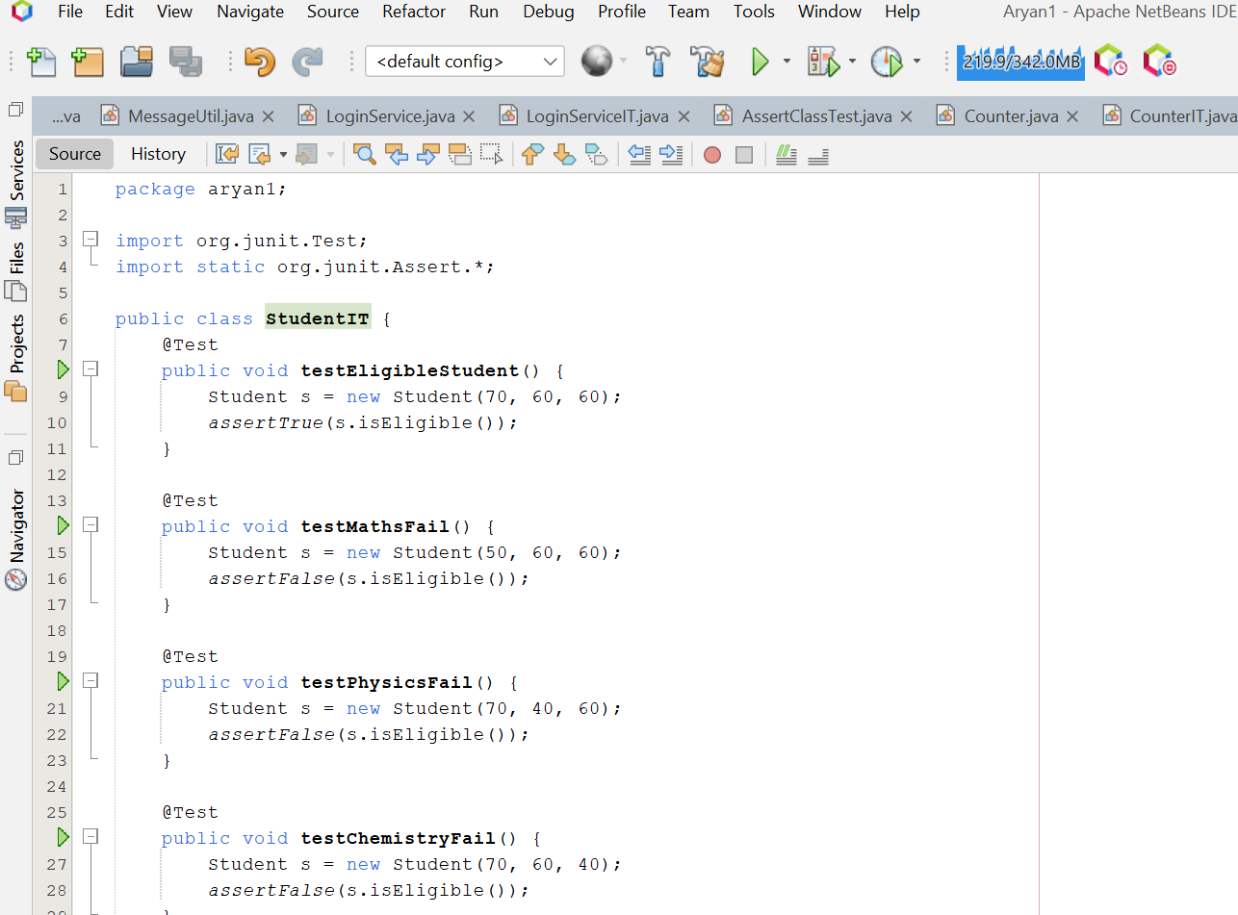
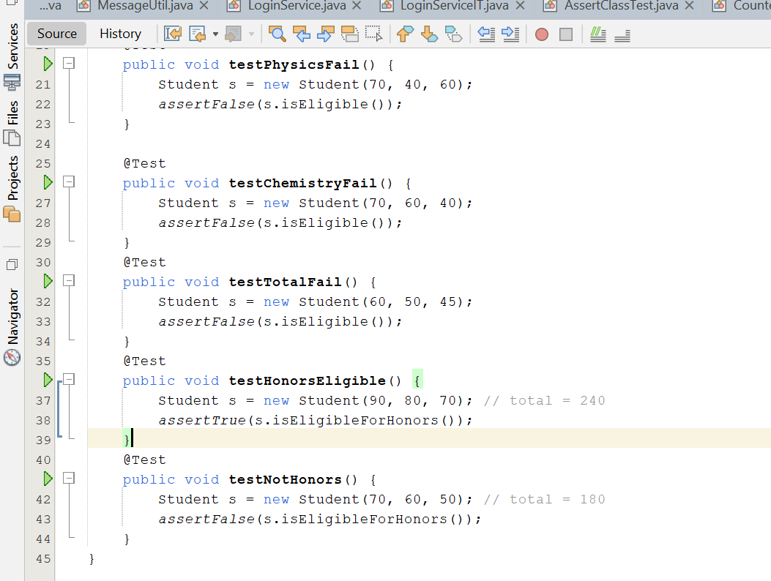
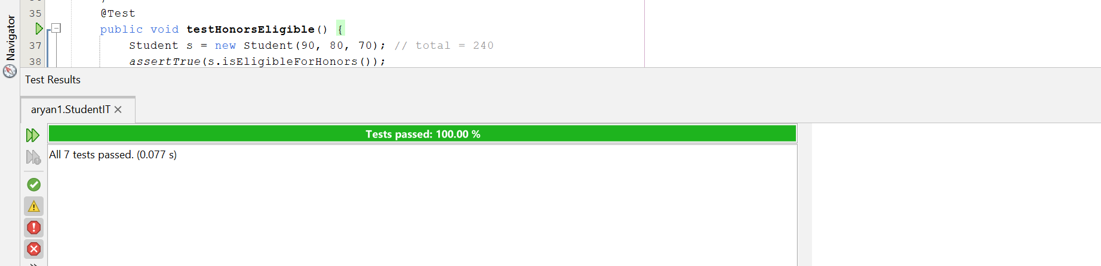
Q20. Demonstrate test driven development through a class MyArray. Write a linear 25- 05- search method to find out the largest element of the array. Design a test class to 2023 test this method, using JUNIT framework. Record both test cases in proper test case templates.

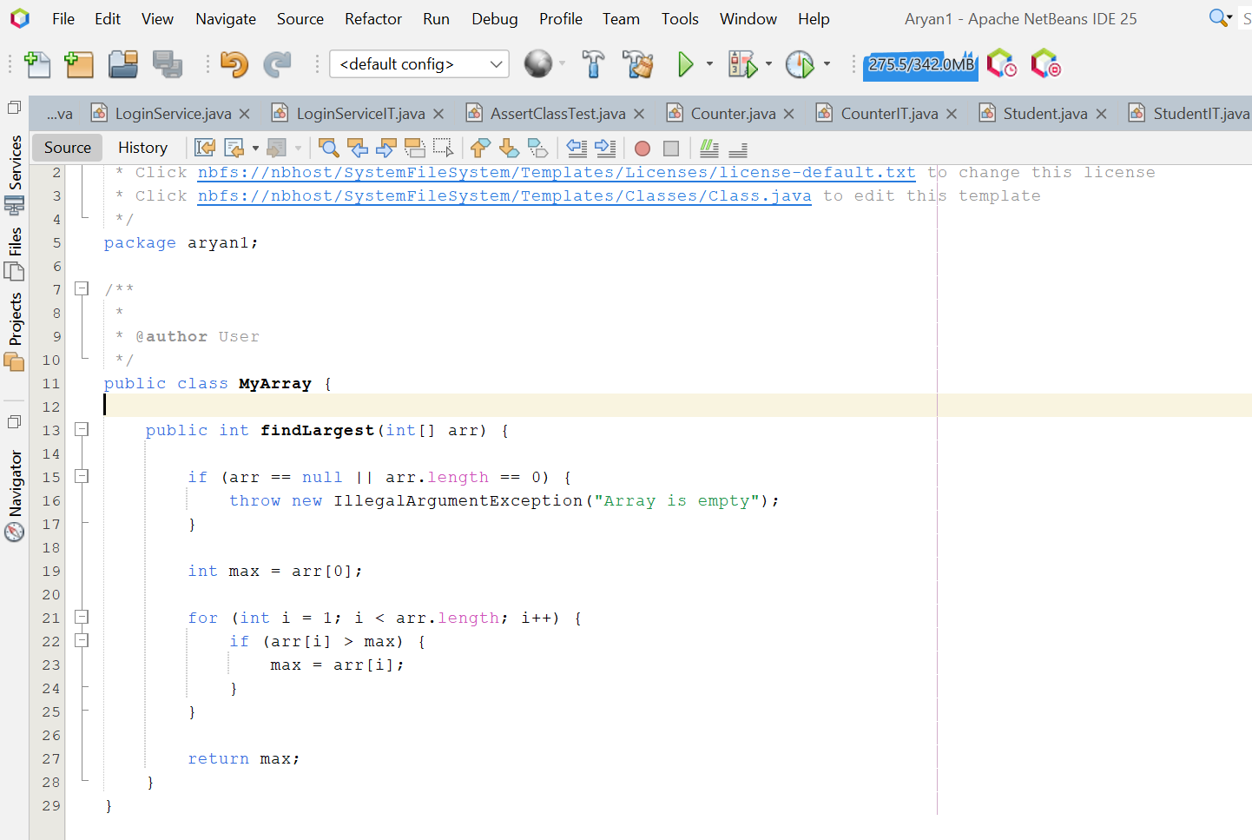
//MyArrayIT.java
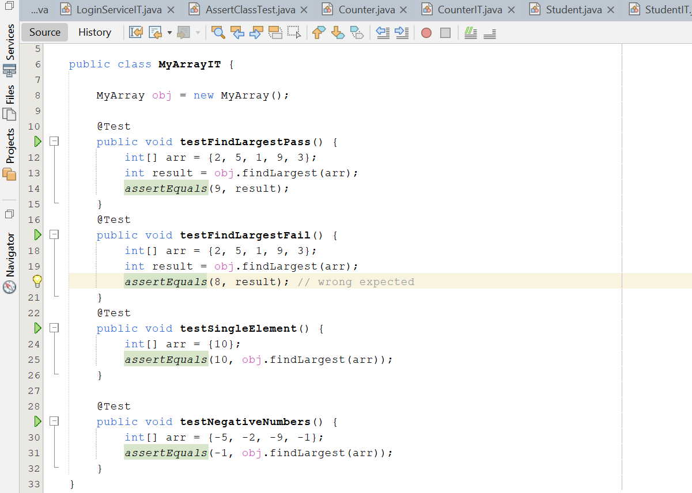
Test Case Ouput:
